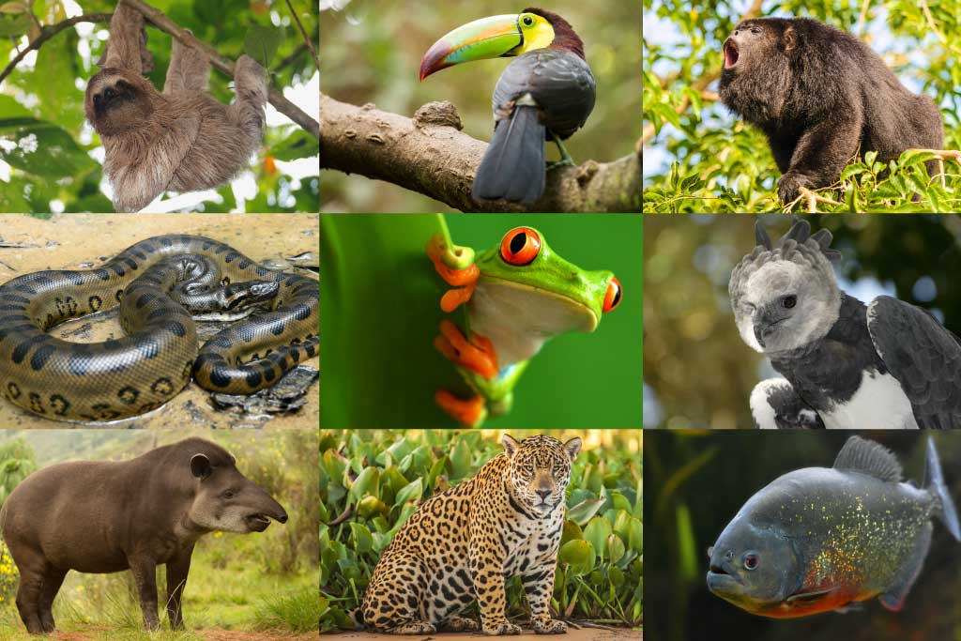
ENQUIRY QUESTION
How does life in temperate Lewes compare with the tropical rainforest?
Rainforests

“He who plants a tree loves others beside himself.”
(English Proverb)

Language of a Geographer

climate | The average weather conditions over a long period of time
deforestation | The cutting down and clearing of forests.
equator | An imaginary circle running round the centre of the earth.
humid | Feeling very damp due to water vapour in the air.
native tribes | The original settlers of an area.
species | A group of similar animals or plants
weather  What are the layers in the rainforest? | The specific condition on a given day

Key questions to ask yourself:
- What is the weather like in the rainforest?
- Do people live in the rainforest? If so, what are their houses like?
- How does deforestation affect us in Lewes?
- How does the rainforest affect me?

Key facts:
- Rainforests cover about 6% of the Earth’s surface
- It can take ten minutes for a raindrop to travel through the rainforest’s canopy to the floor!
- The Amazon Rainforest in South America is so big that, if it were a country, it would be the ninth largest in the world!
- The Korowai people of New Guinea live in tree houses 45m off the ground.
- A quarter of ingredients in modern medicines come from rainforest plants.
- Some trees in Tasmania’s rainforest can live for 2000 years!
Where in The World?

Rainforests are found near to the equator between the tropic of Cancer and the tropic of Capricorn. They can be found in every continent except Antarctica.
They are located in countries such as Brazil,
India, Peru, Mexico, Australia and Malaysia.
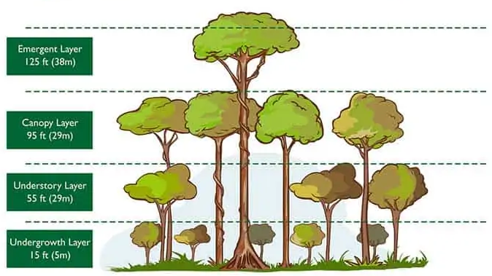

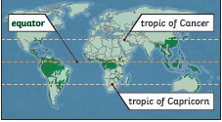
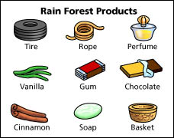

What products come from the rainforest?

Many items that we use every day have actually originated from the rainforest! The world’s most popular fruit, the banana, comes from the rainforest! Other rainforest foods include avocado, vanilla and sugar. Tropical forest oils are used in products such as fuel, paint, soaps and shampoos.

