 |  | Western Road Community Primary School Weekly Maths Plan
 |  | Class: Oak |  | Teacher: R Hamilton |  | Term: Four 2020 | Week Beginning: 16.3.20
Topic: Composition and Calculation: Numbers to 10,000,000
 | Mental Starter/ Revision |  | Introduction |  | Core Group Extension Group Support Group |  |  | Plenary / Assessment / Next Steps
Tuesday | SATS arithmetic questions. |  | WALT: convert fractions to percentages  What facts can the ch identify from this. Ch to draw in books and mark together.  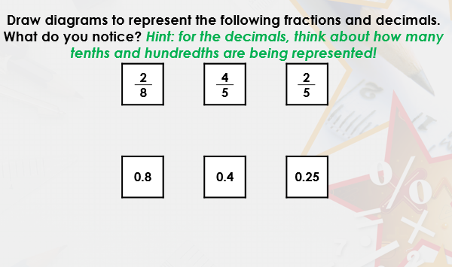  So now can we match the equivalents? |  | Challenge B Model solving similar tasks using presentation – varied fluency 1-4  Challenge B – Questions 5A-8A  Challenge A – Questions 1A-4A – they are similar in structure but with less complex values.  Challenge C – 9A-12A  Star Challenge B Model solving these reasoning chllenges using presentation. Chn make notes as needed and solve problems as a class.  Challenge B – Questions 4A-6A  Challenge A – Questions 1A-3A – they are similar in structure but with less complex values.  Challenge C – 7A-9A |  |  | Discuss findings and misconceptions.  Adults to give feedback/mark work as appropriate.
Wednesday | SATS arithmetic questions. |  | WALT find equivalent fractions, decimals and percantages.  Discuss ways of solving this with chn – can they remember strategies for solving these?  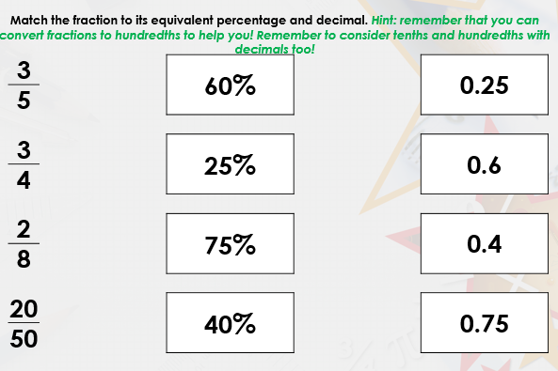 |  | Challenge B Model solving similar tasks using presentation – varied fluency 1-4  Challenge B – Questions 5A-8A  Challenge A – Questions 1A-4A – they are similar in structure but with less complex values.  Challenge C – 9A-12A  Star Challenge B Model solving these reasoning chllenges using presentation. Chn make notes as needed and solve problems as a class.  Challenge B – Questions 4A-6A  Challenge A – Questions 1A-3A – they are similar in structure but with less complex values.  Challenge C – 7A-9A |  |  | Discuss findings and misconceptions.  Adults to give feedback/mark work as appropriate.
Thursday | SATS arithmetic questions. |  | WALT find fractions of amounts – part 1  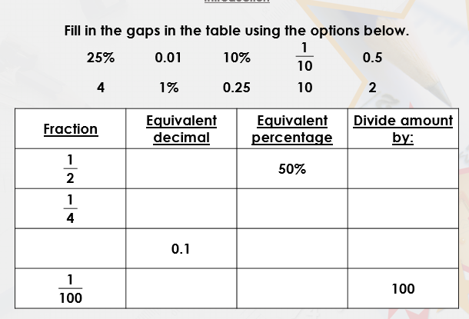  What strategies can we use to solve this? What do you notice about the number we divide by? |  | Challenge B Model solving similar tasks using presentation – varied fluency 1-4  Challenge B – Questions 5A-8A  Challenge A – Questions 1A-4A – they are similar in structure but with less complex values.  Challenge C – 9A-12A  Star Challenge B Model solving these reasoning chllenges using presentation. Chn make notes as needed and solve problems as a class.  Challenge B – Questions 4A-6A  Challenge A – Questions 1A-3A – they are similar in structure but with less complex values.  Challenge C – 7A-9A |  |  | Discuss findings and misconceptions.  Adults to give feedback/mark work as appropriate.
Friday | SATS arithmetic questions. |  | WALT find fractions of amounts – part 2  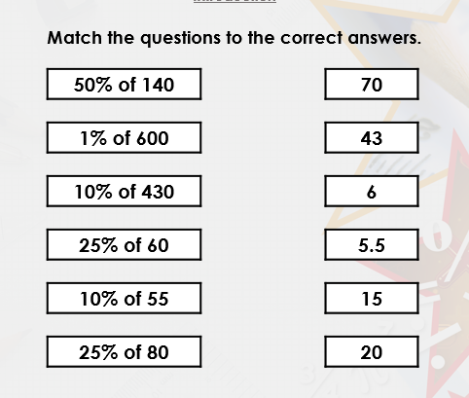  What steps can we follow to solve these? (Find 10%, 1%, 50% as needed) |  | Challenge B Model solving similar tasks using presentation – varied fluency 1-4  Challenge B – Questions 5A-8A  Challenge A – Questions 1A-4A – they are similar in structure but with less complex values.  Challenge C – 9A-12A  Star Challenge B Model solving these reasoning chllenges using presentation. Chn make notes as needed and solve problems as a class.  Challenge B – Questions 4A-6A  Challenge A – Questions 1A-3A – they are similar in structure but with less complex values.  Challenge C – 7A-9A |  |  | Address areas of misconception. Identify areas to review tomorrow.

