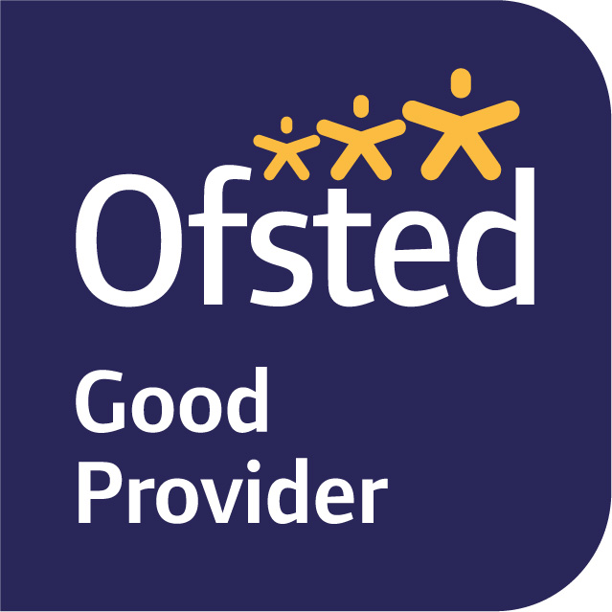

January 2023
Dear Parents and Carers,
Welcome back! I hope you all had a wonderful, relaxing Christmas holiday and are looking forward to Term 3. Our topic for this term is The Great Fire of London which I know a lot of the children have been very excited about.
In English, we will become journalists and research what happened during the great fire so that we can write our own newspaper articles. We will also be looking at Samuel Pepys diary and creating our own entries. Towards the end of term, we will be writing our own fire poems and using some of the artwork we have created to decorate these.
In maths, we have started looking at money and will then move on to multiplication and division. We will start this by looking at equal groups which will then turn in to repeated addition which will then support us with some multiplication problems. Once we are confident with this we will start to look at it in reverse to learn division.
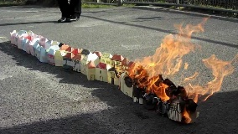
In science, we are studying materials and their properties and have some experiments lined up to help us increase our exploration and data gathering skills. In art, we will be creating our own houses similar to the houses that were destroyed in the fire and are hoping to be able to set these on fire so that we are able to see just how quick and easy it was for the fire to spread when the houses were all so close together! In geography, we are going to be looking at maps of London and creating our own scrap books of famous landmarks and in music we will be getting musical instruments out in order to create our own versions of ‘London’s Burning’.
Our PE session are on Thursdays and Fridays this term, so please could your child wear their PE kit to school on these days. One of our sessions is gymnastics and the other will be developing our co-ordination and agility skills by participating in a range of activities.
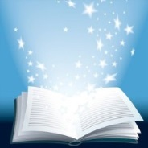
Please can I continue to encourage you to listen to your child read every day. This tiny act will have the greatest impact of any activity on their learning this year. If your child is reading coloured books they will be encouraged to change these once a week during guided reading. They will choose 2 books to take home for the week and then will also be given a sounds write book as usual on a Friday. If your child is on chapter books from the library they will bring home 2 books fortnightly (depending on length) to read as they take longer to read and we have limited access to the library. They will also be given the Sounds Write book on a Friday.
If you have any queries, please do not hesitate to speak to me.
King regards,
Miss Blackwell
Year Two Class Teacher

