**Western Road Community Primary School**

Hello! We are going to be your teachers!

Hello! I am Miss Jones. I will teach you on a Monday, Tuesday and Wednesday.

I can’t wait to meet you. You will love it here at Western Road School!

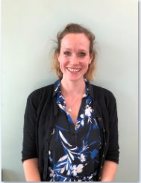

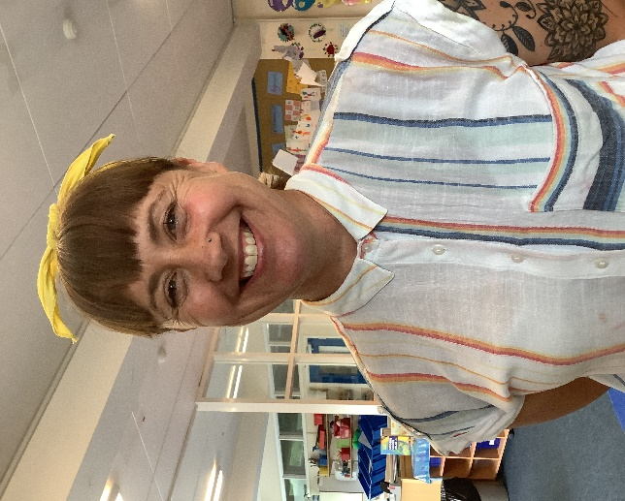

Hello! I am Mrs Reed.

I am a Teaching Assistant in your class and will be there every day when you come to school.

We will have so much fun at school. I can’t wait for you to start!

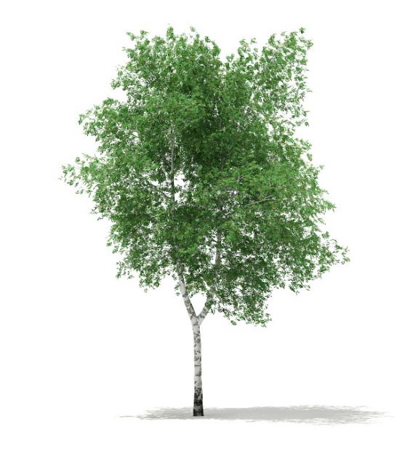

**The name of your class is Silver Birch.**

**When I go to school…**

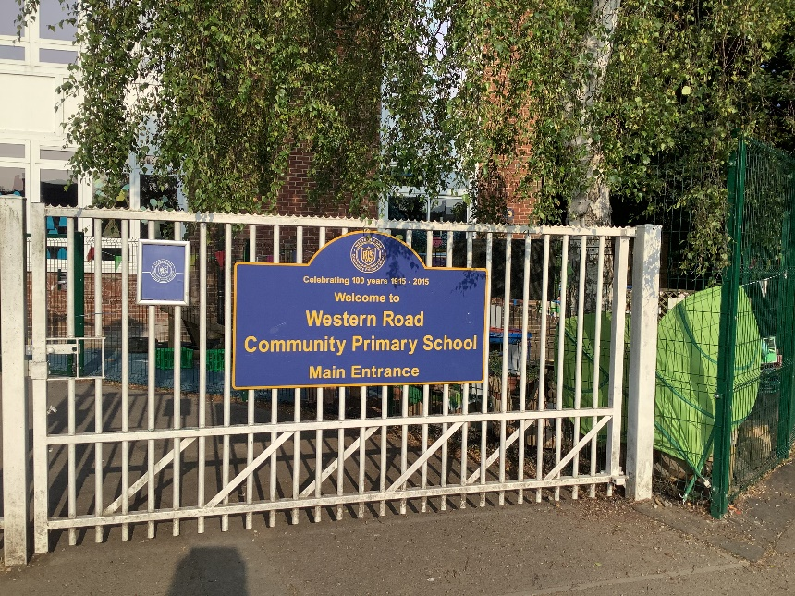

**I will come into school.**

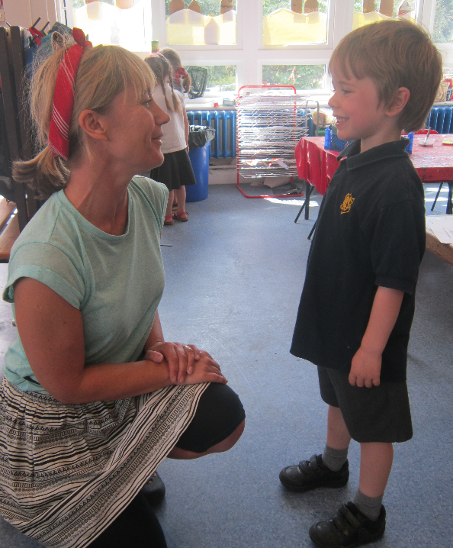

**I will say “Good morning” to my teachers.**

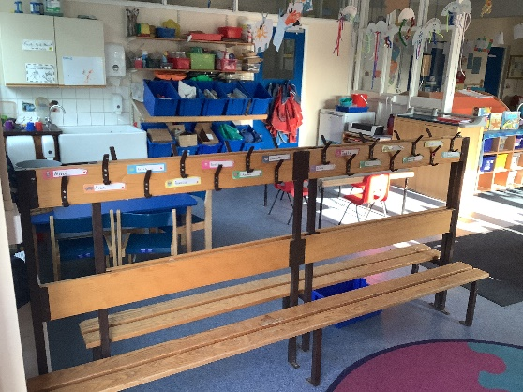 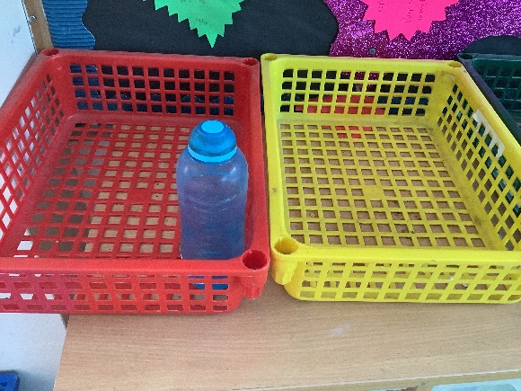

**I will hang my coat and book bag on my peg. I will put my water bottle in the tray.**

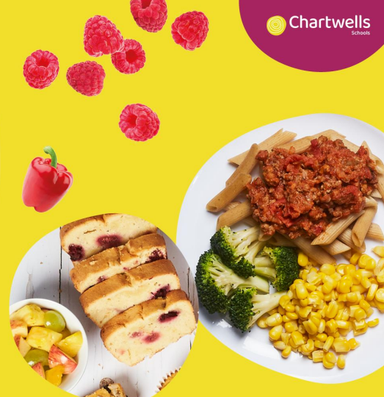

**I will choose what I am having for lunch.**

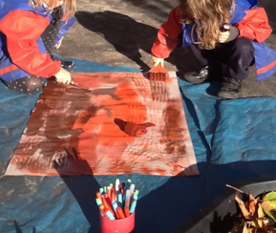

**I can paint pictures….**

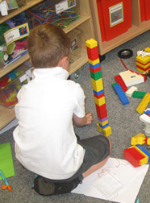

**… and build things with the construction toys.**

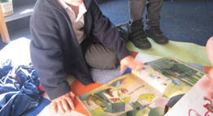

**I can look at books…**

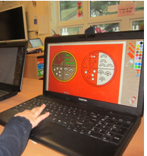

**…use the computer…**

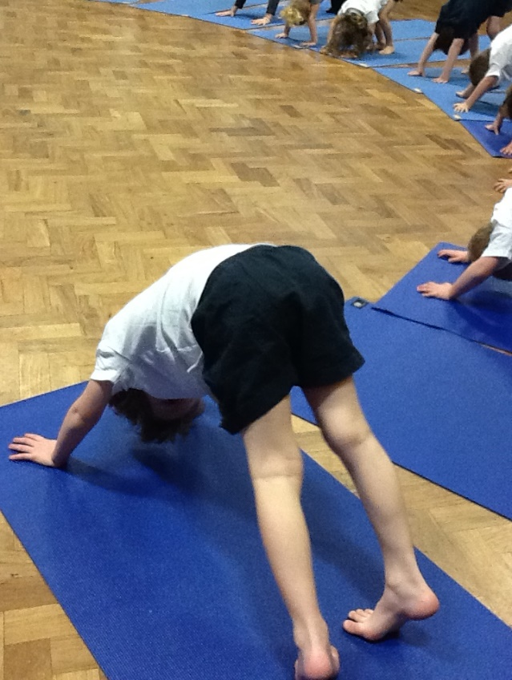

**…and take part in PE.**

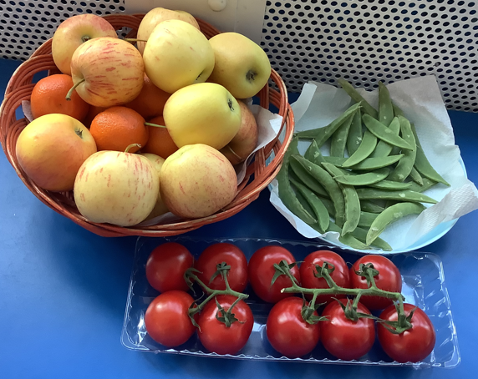

**I will have a healthy snack ….**



**…and help myself to a drink of water.**

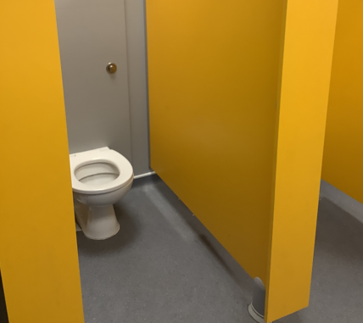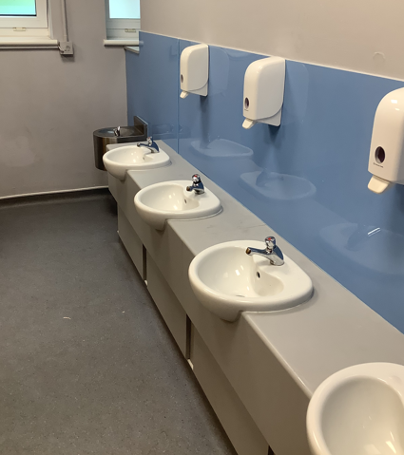

**I will use the toilet when I need to.**

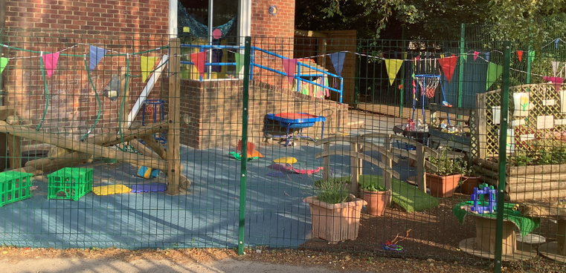

**I will learn and play outside.**

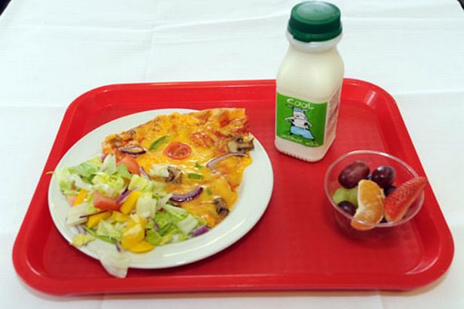

**I will eat my lunch at school…**

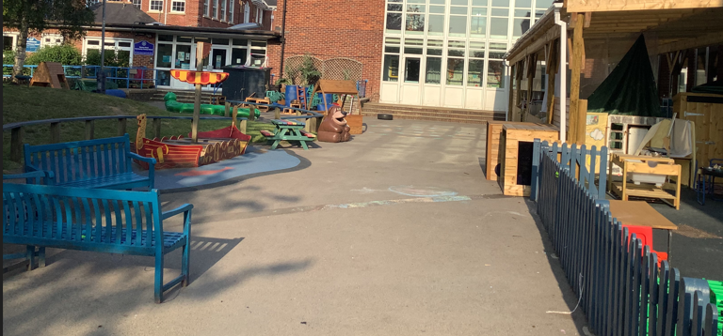

**and play in the playground.**

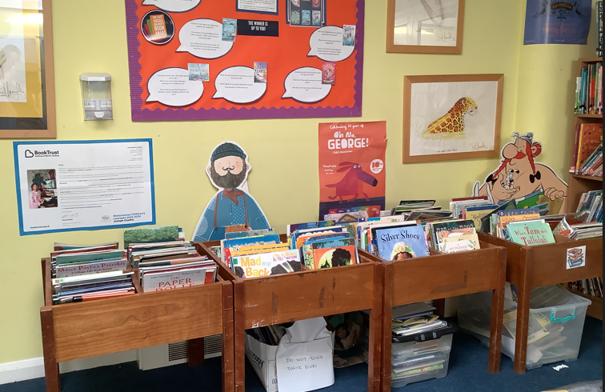

**I will visit the school library….**

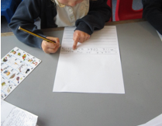

**….write and draw…**

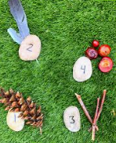

**… and learn about numbers.**

 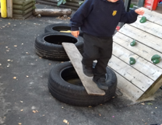 

**I will practise my physical skills….**

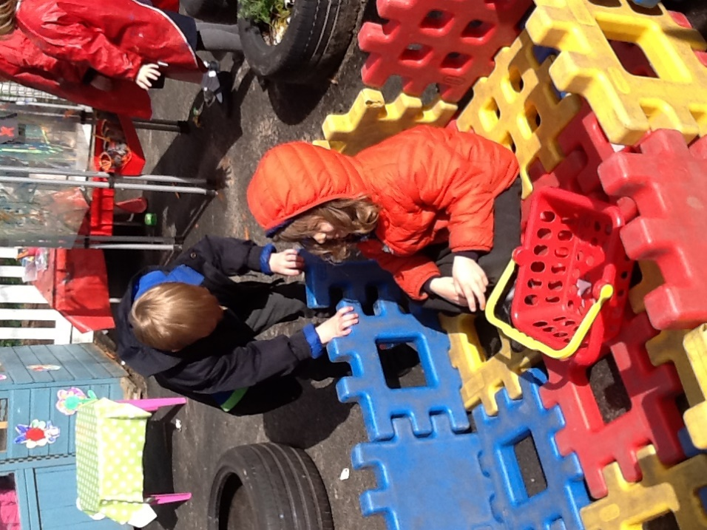

**…and use the big construction to build.**

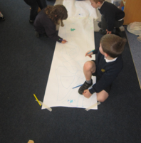

**I will** **have fun at school…**

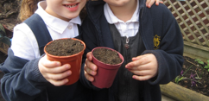

**…and make lots of new friends!**

**We can’t wait to meet you!**