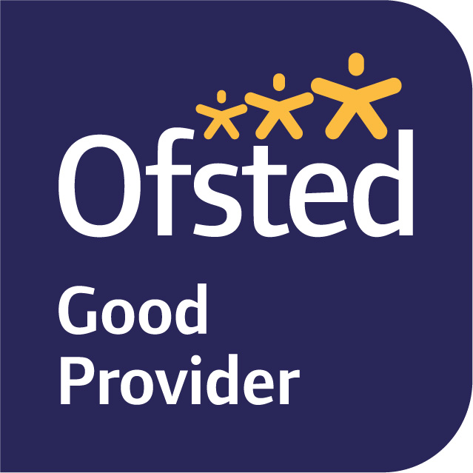

10th June 2022
Dear Parents and Carers,

We hope you have had a restful Half Term Break and we are looking forward to beginning our new topic this term which is Dragons and Castles with our enquiry question being ‘Who lives in a Castle and why?’.

We have outlined below the topic plans for most of this coming term. This will enable you to see what the children will be learning at school and at home.

In English, we will have two focus texts. Firstly we will begin with ‘Tell Me a Dragon’ by Jackie Morris. This text will provide inspiration for children when they write a poem about their own dragon. The children will be reflecting on their previous learning in English on settings, adjectives, verbs and similes to describe their dragon in the poem. We will share our poems with the Year 2 children and look forward to seeing what poems the children produce. We will also be reading Dragon Post by Emma Yarlett. This story will help to inspire us to write letters to our Year 2 teacher to tell them a little about ourselves. We will follow the Talk for Writing approach to ensure the children are confident in the structure and different features that are required to write a letter.

In Maths, we will be covering three units. The first unit will be ‘Introducing weight and volume’. Children have previously learnt about length and height which follows before this unit. The second unit will be multiplication which we have touched on in our Mastering Number work when counting in 2’s and 10’s. The children will develop their understanding of multiplication as repeated addition, understanding the difference between equal and not equal groups. Our final unit will be division which will introduce the children to the concept of equal groups, represented in various concrete, pictorial and abstract ways, including the number line.

In non-core subjects this term we will be linking our learning as much as possible to Castles. Please also see our Term 6 knowledge organiser which provides further information. In Science, we will be naming and exploring different materials in terms of the artefacts and what various buildings are made of. We will be discussing which materials were available in the past and now, for creating objects and buildings. We will be finding out how long objects took to make in the past and now, and make comparisons between the different materials. In Geography, we will be revisiting our learning about seven continents that make up the World in our research about Castles firstly in the United Kingdom and around the World. We will be making maps of our journey to and from the castle looking at the physical and human geography in Lewes. These maps will also incorporate the use of compass directions, North, South, East and West, when talking about directions. In ICT, we are going to be using the IPADS and, through using Scratch Junior, we are going to create our own simple programmes. We will also be learning how to use QR codes which link to websites, to find out further information about historical events, castles or information about artefacts to support their independent learning and research. In History, we are going to be learning about Lewes Castle and the history as to why it was built, who for and how it changed over time. We will be having a school trip to the castle on Thursday 23rd June and will be having a Castle Day on the 5th July (further details are on the knowledge organiser and a trip letter has been sent out.)

In Art we will be inspired by Paul Klee and his painting ‘Castle and Sun’. We will be exploring both colour and shape and, on return from our Castle trip, creating our own ‘Castle’ inspired paintings using black felt tip pens to create the shapes, lines and bold colours to represent the parts of the castle we have chosen to paint. We will also be creating our own tile for printing with. Again, we will be looking at shape when designing our tiles and colour when we use them to print. We are aiming to create a large scale print with all of our tiles together on one piece.

In RE we will be talking and learning about different Bible Stories and how Christians believe Jesus brings good news and how practicing Christians live their lives.

In PSHE and RSE, we will continue to revisit the Zones of Regulation particularly focusing on building tools and strategies to help us in different situations. We will be continuing this work in circle time sessions. Our RSE focus will continue to be Safety. We will covering People who help us outside of school and home and being safe with substances. We will then move onto Citizenship which focuses on why class and school rules are important, discussing the different needs of babies, young children and pets.

This term we are lucky to have another opportunity to attend Yoga on a Thursday afternoon. We will have PE on Monday afternoon, therefore on these two days children can attend school in their PE uniform.

We really hope this helps with giving you an overview of what will be happening this term. If you have any queries, please do not hesitate to contact us, either through the School Office or on Tapestry.

Best wishes.

Yours sincerely,

Mrs Bedford, Mrs Bishop and Mrs Hamblin
Year 1 Class Teachers and Teaching Assistant

