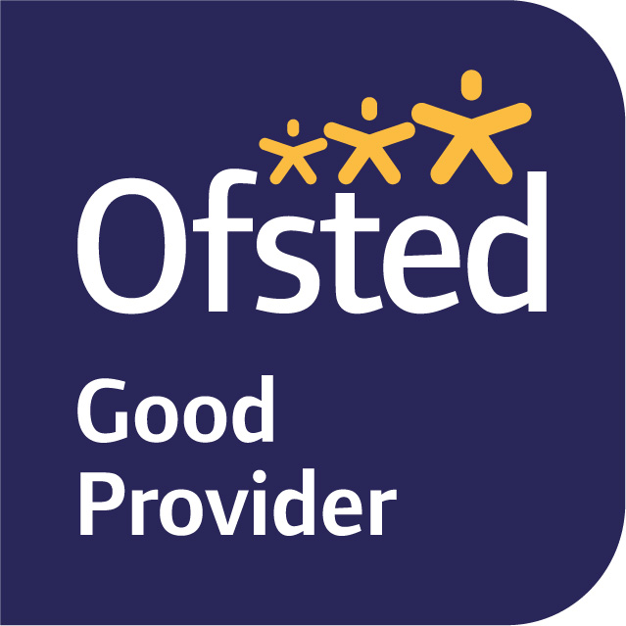

22nd April 2022
Dear Parents and Carers,

We hope you have had a restful Easter Break and we are looking forward to beginning our new topic this term which is Saving lives at Sea.

We have outlined below the topic plans for most of this coming term. This will enable you to see what the children will be learning at school and at home.

In English, our focus text for this term is ‘Storm Whale’ by Benji Davies. Our approach will be through talk for writing whereby the children reflect on their previous learning to imitate, innovate and finally invent a diary entry. We will be also writing instructions for games as part of this unit. As part of our Science we will be extending our reading skills by using non-fiction books and the internet to find information and learn about the 6 different animal groups; mammals, vertebrates, reptiles, fish, amphibians and birds. We will focus our knowledge on animals that live in or near the sea, how the sea supports their survival and the diets they have. We will complete the term with poetry writing.

In Maths, we will be covering two units. The first unit will be ‘Subtraction within 20’. Children have previously learnt about subtraction within 10 and this unit will provide the children with a greater understanding of addition and subtraction being the inverse of each other. The children will revise and taught a range of efficient subtraction strategies. The second unit will be ‘Numbers to 100’. By the end of the unit the children will be able to interpret, order and compare numbers to 100. They will have a good understanding of numbers to 100, including their place value and relative sizes which will enable the children to extend their calculation skills and number knowledge to larger numbers and to an increasing range of situations. We will also be practising their maths fluency on a daily basis to help them secure their recall and automaticity of addition, subtraction. Numbots is a great way to practise their fluency at home.

In non-core subjects this term we will be linking our learning as much as possible with the sea. Please also see our Term 5 knowledge organiser which provides further information. As above, in Science, we will be naming and identifying a variety of animals to include sea creatures, comparing, classifying and grouping them. We hope to also end with a focus on plastic pollution and how we can make a difference. In Geography, we will be revisiting our learning about the five different oceans and seven continents that make up the World. In ICT we are going to be learning how to use the internet safely and how to use different websites to research our topic. We will also learn about algorithms and create our own simple programmes. In History, we are going to be learning about Grace Darling and the story of her life. We will be having a representative from Shoreham lifeboat station visiting the children to talk about the role of the RNLI and they will provide some RNLI kit and videos to support the children in understanding of the important job they do.

In RE we will be focusing on Belonging, revisiting how Christians express their sense of belonging and comparing this to Judaism. We will be learning about the similarities and differences between Judaism and Christianity and the festivals they celebrate. We are hoping to invite a Rabbi to visit the class towards the end of the term to enhance the children’s learning about Judaism.

In PSHE and RSE, we have begun to revisit the Zones of Regulation and are building on tools and strategies to help us in different situations. We will be continuing this work in circle time sessions. Our RSE focus is Safety. We will be learning about adults we can trust inside and outside of school, what to do if we get lost, making emergency phone calls, appropriate contact and safety with substances (substances that are safe and unsafe for our bodies) and hazards at home.

This term we are lucky to have another opportunity to attend Forest School on a Thursday afternoon. You will have received an email from Mrs Hamilton with details of the days and groupings. We will have PE on a Monday and Wednesday afternoon, therefore on these two days children can attend school in their PE uniform.

Later on in the term we are pleased to welcome Mr Matthewson, who is a second year teaching student from Sussex University in our class. The children benefit from having extra adults in the classroom to help and support them with their learning.

We really hope this helps with giving you an overview of what will be happening this term. If you have any queries, please do not hesitate to contact us, either through the School Office or on Tapestry.

Best wishes.

Yours sincerely,

Mrs Bedford, Mrs Bishop and Mrs Hamblin
Year 1 Class Teachers and Teaching Assistant

