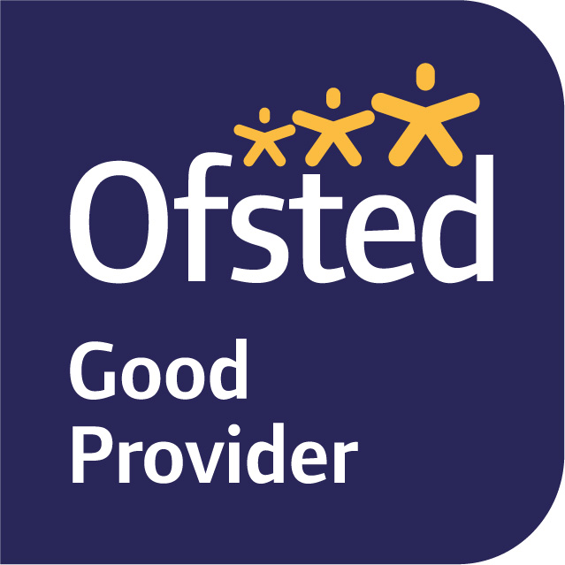

Dear Parents and Carers, 20th February 2023

This term our topic is ALTERNATIVE TALES

In English we will initially be focusing on Poetry. We will learn to recite a poem and create our own poems inspired by our senses and the natural world around us. We will then move onto our Talk for Writing text which is an alternative version of Jack in the Beanstalk. We will be using the children’s existing knowledge of the traditional version of Jack and the Beanstalk to support our learning, exploring imitating, innovating and finally, the children will be retelling the story. We will be sharing our stories with the Reception children once we have written them.

Phonics will continue to be taught daily as a whole-class. Phonics is a fundamental part of the children’s learning in Year 1 and we will be continuing to set homework based on the phonics and writing we have been focusing on each week. We will be sending home the sound write books fornightly as we are aware there is a lot of text in them and also the children can always re read the book again. We ask that you listen to your child read for at least for 5-10 minutes per day. If you would like some further ideas for different ways to read with your child (that isn’t always a school book), please take a look on the English Curriculum section on our school website.
At school, we are reading as part of a guided reading group each week. Every child will be heard by the class teacher as part of their reading group – this will be recorded in reading records as ‘Guided’. Some children will be read to individually more often to help support their reading progress. We will continue to monitor the children’s book levels through guided reading and one to one reading sessions. We are also lucky to have a volunteer who comes to read each week with children in our class. In addition to this, reading is an integral part of our English lessons and daily routine.
In addition to reading, we will begin to send home weekly words for children to practice at home. These words are going to be high frequency words, like said, what or that; we will continue to reinforce the spelling in school. In addition to this, we will be sending home a phonics activity that is linked to current or previous learning in class.
In Maths, we will be covering two areas of learning. We will be learning about weight and capcity and Numbers to 20. The measurement unit will focus on the children comparing and measuring the capacity and weight of objects using non-standard and standard units of measure. In our Numbers to 20 units we will be revising the place value of each digit in a 2-digit number. This is an important skill children will continue to develop when they add and subtract with larger numbers. They will be continuing to partition a two digit number into tens and ones and be able to compare two 2-digit numbers. We will then move onto adding and subtracting Numbers to 20, children will progress form using a counting strategy to using known number bonds to answer addition and subtraction equations. Children will gain a greater understanding of addition and subtraction as the inverse of each other. We will send out the Unit sheets when we begin the new units.

In Science, we will be learning about plants; identifying plants and describing the basic structure of common plants including trees. We will be carrying out tests and recording our results of the most optimum conditions required to enable our bean to grow. The children will be sent a bean seed to plant at home, we hope the children will be able to share and discuss their own bean plants as they begin growing at home. To compliment this topic we are learning which regions of the world our food comes from and we will be studying maps and are hoping to have a workshop from Chartwells to support our understanding of this.

In Design and Technology we are going to solve a problem. Jack needs to get an egg safely down the beanstalk without breaking. The children are going to design and then make their own egg carriers which we will then test with real eggs (boiled) to find out which carrier is the most successful.

In Art we will be looking at sculpture, photography and paintings by the following artists; Andy Goldsworthy and Van Gogh. We are going to reflect on these artists when producing our own artwork.

Our RE focus is going to be Judaism, we will be learning about important festivals in the annual calendar and why they are important to Jews. Our PSHE focus will continue to be health and well-being, and safety, and we will also be linking learning about changing bodies to our Science unit on growing.

Our PE sessions will be on a Tuesday Afternoon and Friday Afternoon. Please ensure your child comes to school dressed in their PE kits on a Tuesday and a Friday.

We really hope this helps with giving you an overview of what will be happening this term. If you have any queries, please do not hesitate to contact us, either through the School Office or Tapestry.

Yours sincerely,

Mrs Bennett, Mrs Bishop and Mrs Hamblin.
Year 1 Team

