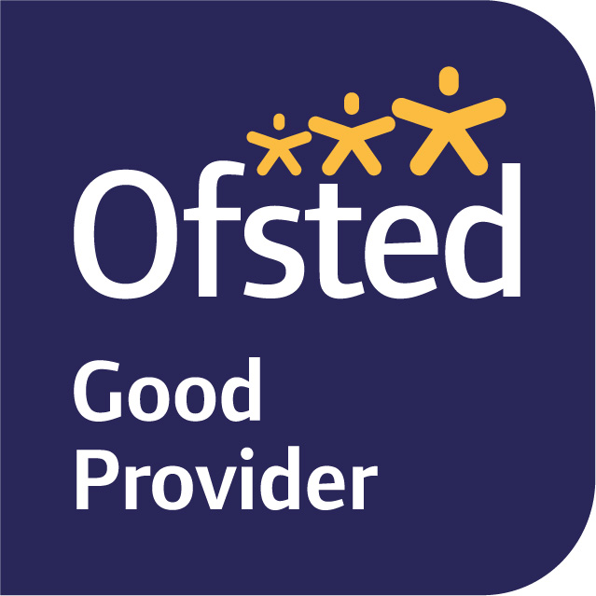

Wednesday 12th January 2022

Dear Parents/Carers,
This term’s topic is DINOSAURS!
In English, we will initially be focusing on the Talk for Writing text The Little Green Dinosaur, where the children will be learning to imitate, innovate and finally invent their own story. We will also be using Little Kids’ First Big Book of Dinosaurs to support our learning about the different periods of dinosaurs and the characteristics of herbivores and carnivores in our Science lessons. We will be learning how to write an information text about a chosen dinosaur and using ICT to create a front cover.
To support the historical aspect of this topic we will be reading a story called ‘The Fossil Girl’ which is about a young girl named Mary Anning who became one of the most famous fossil collectors. We will be visiting the Booth Museum in Hove to take part in a workshop about Mary Anning where we will be sorting fossils, drawing scientific specimens and helping to run her shop ‘Anning’s Fossil Depot’.
To support our Geography learning, our enquiry question is, ‘Where in the World have Dinosaurs been found?’ We will be locating significant places where dinosaurs have been found and will be learning how to use maps and locate places on a map. We will also be comparing two places, learning about the similarities and differences between them.
Phonics will continue to be taught daily as a whole-class. Phonics is a fundamental part of the children’s learning in Year 1 and we will be continuing to set homework based on the phonics and writing we have been focusing on each week. We also ask that you listen to your child read for at least for 5-10 minutes per day. If you would like some further ideas for different ways to read with your child (that isn’t always a school book), please take a look in the English Curriculum section on our school website. At school, we are reading with the children individually and as part of a guided reading group each week. Reading is also an integral part of our English lessons and daily routine. We remind the children that they can change their books when they arrive at school every morning. Please ensure you send their books and reading records in each day.
In Maths we will begin the term by learning about 2D and 3D shapes. The children will learn to name the different shapes and identify the features that determine how they are classified. They will explore the similarities and differences and make distinctions between 2D and 3D shapes. We will then move onto learning about numbers to 50. This unit focuses on interpreting, ordering and comparing numbers to 50. The children will develop an understanding of numbers to 50, including their place value and relative sizes, which will enable them to extend their calculation skills and number knowledge to larger numbers, and to an increasing range of situations. Children will also be introduced to counting in multiples of 2 and 5, and will be encouraged to notice that multiples of 2 end in 0, 2, 4, 6 or 8 and that multiples of 5 end in 0 or 5.
We will continue to send home the information sheet of the unit we are working on so you are able to support your child’s maths learning and be informed of the vocabulary we are using. Please remember that Numbots is a great way to support your child with their understanding of number, we will be presenting certificates each Tuesday which are generated by the programme, based on the number of minutes played and levels passed.
In PSHE we will be focusing on our school theme ‘Courage’ and we will be learning about their Physical, Health and Wellbeing which includes understanding their own feelings, appreciating the differences between their needs and wants and taking some responsibility for themselves and others. In Music we will be learning a song named ‘In the Groove’ and we will be learning how to be in the groove with different styles of music. In RE our focus is ‘Myself’ our focus religions will be Christianity and Judaism. We will be exploring a range of religious stories and sacred writings and talk about their meanings, identify the importance for some people, of belonging to a religion and recognise the difference this makes to their lives. We will also be identifying what matters to them and others.
PE will be on a Monday and Friday, please ensure your child attends school in their PE kit on these days.
If you have any queries, please do not hesitate to speak to either of us before or after school.
Kind regards,
Mrs Bedford and Mrs Bishop

