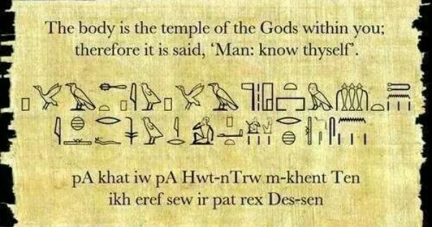
“They were many types of seals, all bearing the insignia of the King.” – Howard Carter
Is there anything left to discover?

(Ancient Egypt)

“To speak the name of the dead is to make him live again.” – Ancient Egyptian quote

Overview
Ancient Egypt was one of the greatest and most powerful civilizations in the history of the world.

It lasted for over 3000 years from 3150 BC to 30 BC.

The civilization of Ancient Egypt was located along the Nile River in northeast Africa.

The Nile was the source of much of the Ancient Egypt's wealth.

Cats were very important and special in Egypt. They were considered sacred.

There were over 2000 Gods and Goddesses in Ancient Egypt

Language of a Scientist
Rocks | A rock is a solid made up of a bunch of different minerals. Rocks are generally not uniform or made up of exact structures that can be described by scientific formulas.  Scientists generally classify rocks by how they were made or formed. There are three major types of rocks: Metamorphic, Igneous, and Sedimentary.
Digestive system | The digestive system consists of the parts of the body that work together to turn food and liquids into the building blocks and fuel that the body needs.
Growing | Plants are living things that grow from the soil and turn light from the Sun into food. Plants can be big or small, from giant trees to tiny patches of moss.
Plants | Plants are living organisms that cover much of the land of planet Earth. You see them everywhere. They include grass, trees, flowers, bushes, ferns, mosses, and more. Plants are members of the kingdom plantae.
seed dispersal | Seed dispersal is the way seeds get away from the parent plant to a new place. "Dispersal" means to spread or scatter.
Water cycle | The water cycle is the path that all water follows as it moves around Earth in different states (solid, liquid and gas).
Requirements for plants to grow | Plants, like all living things, have basic needs that must be met for them to survive. These needs include: light, air, water, a source of nutrition, space to live and grow and optimal temperature.
Key questions to ask yourself
Have we discovered everything about our planet?
Do we know exactly what happened in the past?
How do we know what happened in the past?
Is there anything we do not know or have not discovered yet?

Ancient Egyptian Timeline

Language of a Historian
Ancient | Ancient means belonging to the distant past, especially to the period in history before the end of the Roman Empire.
Tutankhamun | Tutankhamun (Tutankhaten, Tutankhamen) was a Pharaoh of Ancient Egypt. He reigned from when he was nine years old (1334 BC) to when he died (1323 BC).
Tomb | A tomb is a place in which you are buried when you die. The ancient Egyptians believed that life did not stop when you died. What you did when you died was move away to another place, a place they called the afterlife.
Howard Carter | Howard Carter was an English archaeologist and Egyptologist. He became world-famous after discovering the intact tomb of Tutankhamun in November 1922, the best-preserved pharaonic tomb ever found in the Valley of the Kings.
Papyrus | Papyrus is a kind of paper that was used in Ancient Egypt for writing.
Pharaoh | As ancient Egyptian rulers, pharaohs were both the heads of state and the religious leaders of their people. The word “pharaoh” means “Great House”
Artefact | An artefact is a man-made object, such as pieces of art or tools, that is of particular cultural, historical or archaeological interest.
Archaeologist | Archaeologists are scientists who study the history of humans by looking at what man-made objects were left behind.
Sarcophagus | A sarcophagus is a stone coffin or a container to hold a coffin.The earliest stone sarcophagi were used by Egyptian pharaohs which reigned from about 2686 to 2613 BC.
Language of a Geographer
River Nile | The Nile is the longest river in the world. It flows through northeastern Africa for about 4,132 miles (6,650 kilometres).
Seasons (farming) | Egyptian farmers divided their year into three seasons, based on the cycles of the Nile River.
Fun Facts
The Egyptians were lucky as they lived along the River Nile. This meant that they could use the water to grow crops, to get food from and for soil.

When a loved one had passed away, they believed in preserving the body, which was called mummification. The Egyptians believed that this would make their soul live on forever.

The Ancient Egyptians were kept busy by building pyramids! So far, over 130 pyramids have been found in Egypt. Archaeologists are still looking for more!

Egyptians were great at coming up with things to heal the human body. They used mouldy bread to heal wounds quickly and to stop infection and a lot of the time, it worked! It was trial and error as they had no idea how it worked!

Ancient Egyptian men and women wore make-up. It protected their skin from the hot sun but they also believed it had healing powers too. They usually wore green and black make up. The green was made from copper and the black was lead!

The Egyptians were great at inventing! They invented medicine, musical instruments, paper, pens, locks , keys, cosmetics and even… toothpaste!

7500 BC  First settlers arrive at the Nile valley | 2640 BC  The first pyramid was built. ‘The Step Pyramid’ | 2555 BC  The pyramids of Giza were built for Three Kings. | 2520 BC  The Great Sphinx was built. | 2000 BC  Ploughs were first used. They revolutionised farming. | 1332 BC  10 year reign of Tutankhamun started. | 51 to 30 BC  Cleopatra rules. Romans take over control and ‘Ancient Egypt’ ends. | 1922  Howard Carter discovers tomb of Tutankhamun
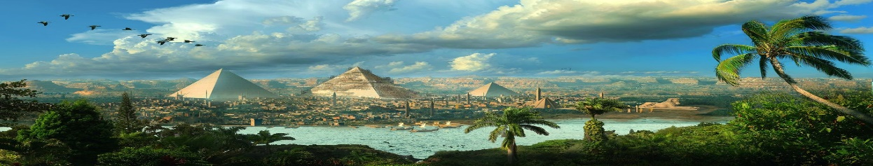
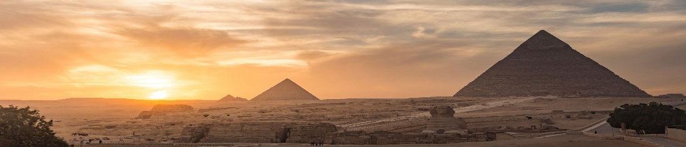
The Power of Curiosity – knowledge organiser

