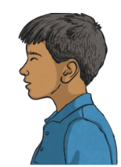
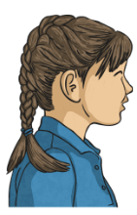
What do you think Livia and Tranio might be talking about? Plan out your ideas here. Are they happy with each other? Is this before or after the eruption?
Tranio
Livia

