|  |  |
| --- | --- |
| **Language of a Map Maker** | |
| **Scale** | The ratio of a distance on a map to the real distance on the ground. |
| **Directions** | 4 key compass directions: North, South, East and West.  More complex compass direction: North East, North West, South East and South West |
| **Contour lines** | Lines on a map that join places of equal height. They are usually shown as fine brown lines on a map. |
| **Coordinates** | A group of numbers and letters used to indicate a position on a grid |
| **Grid reference** | A map reference indicating a location in terms of a series of vertical and horizontal grid lines |
| **Ordnance Survey** | Detailed maps of Great Britain where each square represents 1km squared. |
| **Bird’s eye view** | A photo taken from the air or from above |
| **Key** | A key explains the meaning of symbols on a map. |
| **Compass** | A tool used for showing direction |

|  |  |
| --- | --- |
| **Language of a Geographer** | |
| **Coast** | The part of a the land which joins to the sea |
| **Hills** | A naturally raised area of land |
| **Mountains** | A large naturally raised area of land |
| **Rivers** | A large natural stream of water flowing in a channel to the sea. |
| **Region** | A specific part of a country with no fixed boundaries |
| **Country** | A nation with its own government |
| **County** | A way of dividing up a country into smaller areas. Lewes in in the county of East Sussex. |
| **City** | A large town usually with a cathedral and often with a university. Brighton and Hove is a city. |
| **Town** | A built-up area with a dense population and local government. Lewes is a town |
| **Village** | A group of houses with a few buildings such as shops, schools or churches. |
| **Rural** | Areas in a country with a smaller population. Usually in the countryside. |
| **Urban** | Areas in a country with a larger population. Usually in a city. |

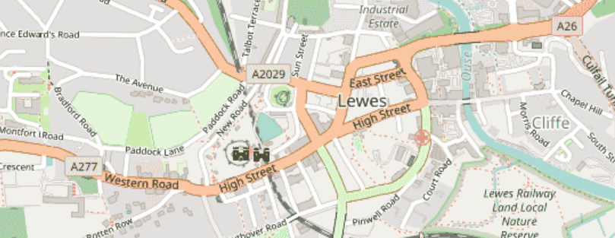

**What do maps tell us about the UK?**

**“I wisely started with a map!” J.R.R Tolkien**

**“A map tells you where you’ve been, where you are and where you’re going – in a sense it’s three tenses in one.” Peter Greenaway**

|  |
| --- |
| **Activities to try at home** |
| * Find a map at home and talk about what it represents. * Create a bird’s eye view map of a room at home. * Create a map of your house and the local area around you. * Research a place in the UK and compare it to Lewes. * Look at fiction books that have maps related to the story. * Have a look on google Earth and explore the UK. |

|  |
| --- |
| **Key diagrams and symbols** |
| Reading Topographic Maps | NRCS New Hampshire  Scale bars—ArcGIS Pro | DocumentationDirections and angles |

|  |
| --- |
| **Key questions to ask yourself** |
| How are maps useful?  Are there different maps?  What is the difference between physical and geographical features?  What are the benefits of using maps?  How have maps changed over time?  What maps do you find easiest to read? Why? |

|  |
| --- |
| **Fun Facts** |
| * **The UK is made up of 4 countries – England, Northern Ireland, Scotland and Wales** * **Great Britain is the name for three nations on the main isle: England, Scotland and Wales** * **No location in the UK is further than 77 miles away from the sea.** * **The UK’s highest mountain is Ben Nevis in Scotland which is 4412ft tall!** * **The UK’s longest river is the river Severn which is 220 miles long.** * **Stonehenge is known as the oldest monument in the world dating back 3000 years.** |

|  |
| --- |
| **Overview** |
| * **What are the similarities and differences between a village, town and city?** * **How can I describe Lewes?** * **What does Lewes look like on a map?** * **How does Lewes compare to London?** * **What are the key features in urban or rural areas?** * **How do maps show these key features?** * **How can I use coordinates and grid reference to show directions?** |