How are our lives different to those living in another country?
INDIA

Indian culture
Flag | National bird | Traditional Indian food | Traditional Indian clothing
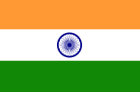 | 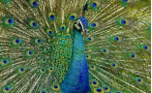 | 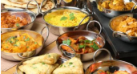 | 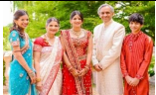
Language of a Geographer
United Kingdom | Island in Europe made up of 4 countries: England, Ireland, Scotland and Wales.
India | A country in Asia.
Climate | The weather and temperature in a place.
Population | How many people live in a certain place.
Mumbai | The largest city in India.
Culture | Beliefs, ideas and different ways of living for different groups of people.
Coastal | A stretch of land along the sea.
Urban | A town or city.
Comparisons between India and the UK
 | India | The UK
Continent | Asia | Europe
Capital cities | New Delhi | England – London
Population | 1.38 billion (2020) | 67.22 million
Climate | India has three major seasons - winter - summer and the monsoon.  Winter months (November-March) are bright and pleasant, with snowfall in the northern hills.  Summer time (April-June) is hot in most parts of India, and it is then that the numerous hill resorts provide cool retreat.  During the monsoon, rainfall is heavy along the west coast between June and September, and along the east coast between mid-October and December. | The UK has 4 seasons – Winter – Spring – Summer – Autumn  Generally the United Kingdom has cool to mild winters and warm summers with moderate variation in temperature throughout the year.

