January 2024
Dear Parents and Carers,

We began the term in Cherry Class by learning about germs and the importance of washing our hands through a series of experiments for Healthy Living Week. We have also looked at keeping healthy through a balanced diet and a healthy mind. This week, we have started our topic learning with a ‘flight’ to India!
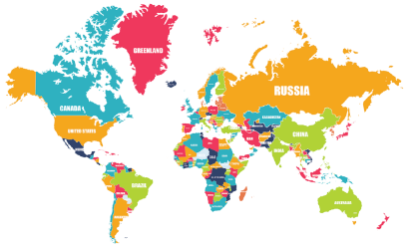
Throughout the term there will be a lot of thinking like a geographer! We will be using maps to find the UK and India. We will also be looking in to the human and physical features of both countries and comparing them.

In science, we are focussing on animals including humans and their basic needs for survival as well as life cycles and food chains.

We will be creating many pieces of bright, patterned art work this term starting with some mehndi designs and then moving on to rangoli patterns and shadow puppets.

In music, we will be exploring music from around the world and will look at the different types of instruments that are used.

In Maths, we have started learning about the properties of 2D and 3D shapes and how we can identify them. If you would like a deeper understanding of how this will be taught in lessons please have a look at the videos on this link. https://whiterosemaths.com/homelearning?year=year-2
You do not have to work through these with your child. However, they are useful for your own understanding of the vocabulary and process we use for teaching them.

In English, we are focussing on the story ‘Chapatti Moon’ which follows a similar pattern to ‘The Gingerbread Man’. The children will eventually end up with their own original stories based on this structure. We will also be looking at the traditional Indian folk tale ‘The Tiger Child’ and the story of ‘Rama and Sita’.

PE this term is on Mondays and Fridays. We will be focussing on ball skills and fitness. We will try to be outside for some of these lessons so please ensure your child wears a suitable jumper for these days.

Kind regards,
Miss Blackwell
Year Two Class Teacher

