Special Educational Needs Information Report
Western Road Community Primary School
2023-2024

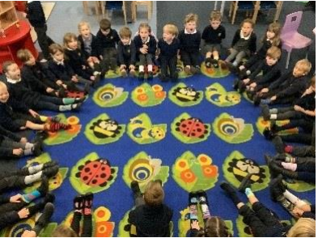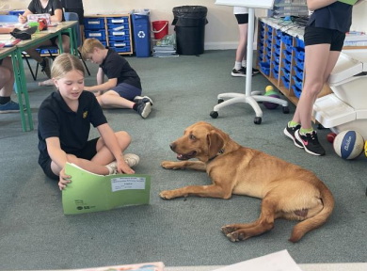

Contents

1. About this report
2. Who do I contact about my child’s special educational needs and disabilities?
3. Who supports children with SEND?
4. Which children does the school provide for?
5. How do we meet the needs of our learners, including those with SEND?
6. How do we identify children’s special educational needs?
7. How do we teach and support children with SEND?
8. How will the curriculum and learning environment be matched to the child
/ young person’s needs?
9. How are pupils/young people with SEND included in activities with other
children, including school trips?
10. How are parents and carers involved in reviewing children’s/young people’s progress and planning support?
11. How are children involved in reviewing their progress and planning support?
12. What training do the staff have?
13. How does our setting measure how well it teaches and supports children
with SEND?
14. How accessible is our setting and how does it arrange equipment or
facilities children need?
15. What support is there for children’s/young people’s overall well-being and
their emotional, mental, and social development?
16. What specialist services do we work with to support children and their families?
17. Where can I get information and support?
18. What should I do if I’m not happy?

1. About this Report
(SEND CoP 6.81)

The Children and Families Act 2014 says that all maintained schools must publish a Special Educational Needs (SEND) Information Report every year. This report explains how our school meets the needs of children with SEND. It will be shown on our school website and in the ‘local offer’ on www.eastsussex.gov.uk

In the report, we explain how we meet our duties towards children with special educational needs and disabilities. Further information can also be found in our SEND policy. For more information on the law and guidance we follow, see www.eastsussex.gov.uk/localoffer

We will review this report every year and will involve children and parents through regular consultations and meetings. If you want to give us your views about the report, please contact the school office.

Hilary Turner (Chair of Governors)

2. Who do I contact about my child’s special educational needs?
(SEND CoP 6.79 bullet 5)

If you are thinking of applying for a place, contact the School Administrator, Linda Johnson through the school office.

The school telephone number 01273 473013, or you can email the school office on office@westernroad.e-sussex.sch.uk , who will forward on your query.

The Special Educational Needs Coordinator (SENCo) is responsible for managing and co-ordinating the support for children with additional or special educational needs, including those who have Education Health and Care (EHC) plans. The SENCo also provides professional guidance to school staff and works closely with parents and other services that provide for children in the school.

Kerry Bedford is our school’s SENDCo.
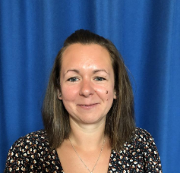
How to contact: please telephone 01273 473013 or email:
senco@westernroad.e-sussex.sch.uk

Best time to contact – Working days are Monday, Wednesday or Thursday
Governors for SEND: Tom Jeffery and Karen Wallis (contactable via the School Office)

3. Who supports children with SEND?

For children already in our setting, all staff support pupils with SEND including class teachers and support staff.

Teachers know the children in their class well and will be aware of the strengths and needs of all pupils, including those with SEND. Teachers are your first point of contact if you have any queries or concerns about your child, their wellbeing or progress. They are available every day after school at pick up for check ins, or an appointment can be made via the school office for a more in depth discussion. You can also email the school office who will pass your email onto your child’s teacher. All of the teachers in our school have Qualified Teacher status and Western Road Community Primary School ensures all staff have ongoing professional development to enable high quality teaching in every classroom.

4. Which children does the school provide for?
(SEND CoP 6.79 bullet 1)

We are a maintained inclusive primary school. We offer an exciting and engaging learning environment for pupils from the age of 4 to 11 years old. We provide provision for children across all areas of needs, including
communication and interaction, social emotional and mental health, cognition and learning, and sensory and physical needs.

We use the East Sussex SEND Matrix to guide the provision and resources to meet needs and facilitate progress for our pupils. This is a framework that has been drawn up by the Inclusion, Special Educational Needs and Disabilities service (ISEND)
in collaboration with parents, carers and staff from educational settings across the county. The purpose of the SEN Matrix is to -
• Provide a shared understanding for schools, the Local Authority,
parents/carers, and services such as Health and Social Care, about how to
identify the Special Educational Needs of children and young people
• Provide guidance on provision and resources recommended to meet these
needs, and to facilitate educational progression
• Support development of knowledge and understanding about SEN
• Contribute to the development of good SEN and inclusive practice (‘build
capacity’)
• Provide a framework from which the Local Authority and its moderation
partners will make consistent decisions about funding levels for children to
facilitate their educational progression.

You can access the Matrix, on East Sussex czone page, using this link –
https://czone.eastsussex.gov.uk/inclusion-and-send/sen-matrix/the-matrix/

If you would like a place for your child with an Education Health and Care Plan, contact your Assessment and Planning Officer at East Sussex County Council. If you want a place for any other child with special educational needs, you should apply as normal and your application will be considered in the same way as applications from children without special educational needs.

- Western Road Community Primary School - admissions policy can be found on our website
- School admissions - contact Information for Families for admissions advice - 0300 330 9472
- If you want a place for a child who has a statement or Education Health and Care Plan, contact your Assessment and Planning Officer at East Sussex County Council. If you want a place for any other child with special educational needs, you should apply as normal and your application will be considered in the same way as applications from children without special educational needs.

5. How do we meet the needs of our learners, including those with SEND?

At Western Road we aim to include all children, regardless of their need, in the life of the whole school community. We aim to do this in a way that involves the views of parents and the children themselves, respecting individual beliefs, tradition and culture. This is in accordance with the Children and Families Act 2014 and the Equalities Act 2010.

In our reception class, children are encouraged in a warm and supportive way to learn through play and stimulating and meaningful activities. This is built upon in Year 1 and Year 2 as children have opportunities to take part in activities in our areas of learning provision. Learning is active and exciting. The EYFS and KS1 team ensure activities meet the needs of the individuals.

In all of the school, exciting and engaging learning takes place. Every pupil has access to a broad, balanced and creative curriculum. We set high expectations for all pupils. Our curriculum is based on the school’s values and developing pupils' awareness of how they learn best as individuals. This is further underpinned with understanding of their own physical and mental wellbeing which is interwoven throughout the curriculum. The emphasis is on learning from first-hand experience and existing knowledge, developing skills, knowledge and understanding in practical and relevant contexts, with an awareness of how they are learning. The National Curriculum, which guides teachers in the content of children’s learning, is at the heart of the teaching programme. Children’s learning will often be based around an enquiry question and may include several curriculum areas. While thematic topics vary from term to term, or each half term, the core skills of English and Mathematics are taught consistently throughout the year. Quality first teaching across every age phase meets the majority of pupil needs.
This is defined as teaching which uses inclusive strategies as day to day
practice. It means that learning begins from each pupil's own starting point within their learning, and builds from there. Examples of this in practice in our
school include the use of visuals and kinaesthetic learning strategies, effective
use of differentiated questioning, linking into and building on prior learning and metacognition to support the development of independence for all pupils. Quality first teaching means that teachers plan highly engaging activities which allow children to access the learning in different ways in order to meet the individual’s needs in their class. It also means that tasks are delivered using a personalised and scaffolded approach for pupils.

Children who need further support are provided with a range of one to one or small group work targeted to meet their needs. This work focusses on a range of needs, for example, academic, pre-teaching, emotional or social. This work is carried out within the classroom environment, following quality first teaching and teacher assessment within lessons, or in our various intervention spaces; the gallery area, the library or our Rainbow Room (small room). Pupils requiring intervention are identified by the class teacher and SENCO. Intervention are planned, delivered and reviewed by class teachers, support staff and/or the SENCO. To be effective the interventions are targeted based on pupil need and progress and are for a set period of time, usually six weeks. The SENCO works with class teachers and support staff to support and advise them in delivering high quality teaching and oversees the additional interventions. Teachers and support staff are enabled to support a range of needs through regular training and professional development opportunities throughout the school year. All teachers and support staff are part of the Performance Management cycle which is overseen by the Head Teacher and Governing Body.

We have highly trained support staff who deploy a range of supports in school, either in class or through targeted interventions. These include staff trained to provide speech and language support, play therapy, emotional regulation groups, phonics interventions, sensory and jump ahead groups.

The support and needs of children with SEND are regularly reviewed and updated using Additional Needs Plans where a SMART Target approach is taken. The `assess, plan, do, review` cycle of monitoring children`s progress is a key element of our good practice.

If the child is looked after by the local authority they will have a Care Plan including a Personal Education Plan (PEP) and a Health plan. We will coordinate these plans with the SEND support plan and will involve parents and carers as well as foster carers or social workers in discussions.

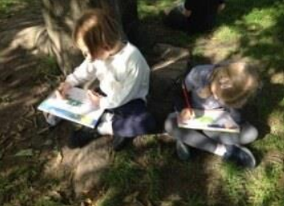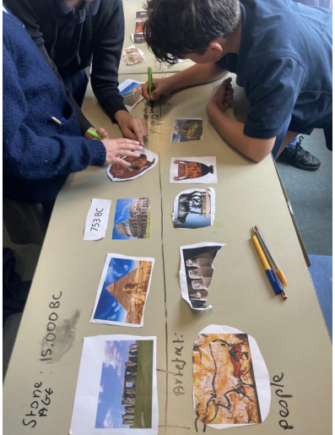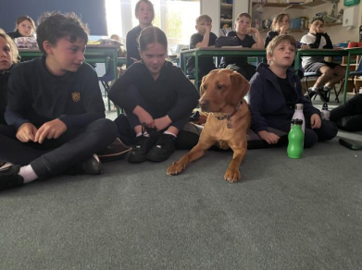

6. How do we identify children’s special educational needs?

We aim to identify children’s special educational needs (SEND) as early as possible, so that the child achieves the best possible outcomes. We assess each child’s skills and level of attainment when they start at the school. We continually assess each child’s progress. If a child is making less than the progress we would expect for their age or individual circumstances, we will consider whether they have special educational needs.

The SENCo will gather evidence from the class teacher and support staff who are working with the individual child and build up a picture of what the child`s level of attainment is. If it is well below what is expected at their age then the SENCo will carry out assessments and observations of the child to try and identify any learning difficulties that the child may have. The SENCo will then advise the class teacher about ways forward for the child within the class setting, through quality first teaching in the first instance. If progress continues to be slow the SENCo and the class teacher will liaise about intervention work and how this will be best delivered by the school team.

If a child presents with behavioural difficulties we would consider them to have special educational needs if their behaviour, over time, is creating a barrier to their academic progress and positive interaction in the school community. All behaviours are a form of communication and we aim to listen, understand and support children through a range of strategies and tools.

Similarly if a child speaks English as an additional language, then they would be identified as needing special education support. Our teaching, learning and assessment policy can be found on our school website.
A child has SEND where their learning difficulty or disability calls for special educational provision. That is, provision which is different from or additional to what is available to children of the same age.

Children may have one or more broad areas of special educational need:

• Cognition and learning
– including developmental delay and specific learning difficulties such as dyslexia, dyscalculia and dyspraxia.

Progress is monitored for all pupils at Western Road School throughout the school year. Pupils who are not making the expected academic progress are identified through pupil progress meetings, class drop ins and learning walks, and through data tracking. Strategies to support them further in the classroom are planned with class teachers and SENCo and put into place initially. This is reviewed after implementation. If progress remains slower than expected further assessments for additional needs are undertaken, a Pupil Support or Additional Needs Plan may be considered at this point or a referral may be made to external agencies if appropriate. If an Additional Needs Plan is begun, the pupil will go onto the school’s SEND register. Each stage of this process is discussed with parents who are invited to contribute their thoughts and wishes to the plan. If the strategies are successful over time and the pupil no longer requires additional support, this is noted on the pupil’s file. The pupil may come off the plan and the SEND register.

• Communication and interaction
– including speech and language difficulties and autism.

We follow the recommended process from East Sussex Speech and Language Service. All pupils are screened using the Language Link Program in Reception, which identifies any developmental language difficulties. If an area is identified as needing support, this is provided by our Speech and Language Teaching Assistant, Mrs Reed. Those pupils are then re-assessed later on following this intervention. If difficulties remain, in liaison with parents/carers, we submit a referral for an assessment from the speech and language
therapy service. If later on in their school lives parents/carers or a pupil’s teacher has concerns around speech and language this can be explored by
with the school SENCo. If appropriate, an Additional Needs Plan can be put into place for as long as additional support is needed. The pupil would then be on the SEND register for the time this plan is in place.

We work closely with the CLASS (Communication, Learning, Autism Support
Service) to support pupils who have a diagnosis in this area – see below for more information.

• Social, emotional and mental health difficulties
– including difficulties with behaviour, attention deficit hyperactive disorder, an attachment disorder or anxiety.

Our support staff run social skills groups, friendship groups, emotional well-being groups supporting pupils who may need support in these areas, or are experiencing anxiety. They do so in close collaboration with the class teacher and SENCO. Concerns regarding possible additional needs around social communication may be raised by teachers and / or parents / carers and are discussed fully with parents / carers before deciding on the next steps. These
decisions are always made together, and may lead to Additional Needs
plans being put in place, and / or referrals in order to get an assessment
and possible diagnosis. We are also able to offer signposting to other
support services for the pupil, their parents /carers and siblings when
this is helpful.

Our school’s behaviour for learning approach is based on expectations that are underpinned by the fundamental value that all members of the school community are be treated with courtesy, respect and understanding. We follow an Emotional Regulation approach where pupils are encouraged to understand their feelings and emotions, and how they may feel or react in different emotional states. This policy is available to view on our website. Pupils demonstrating behavioural needs are monitored and observed in order for the underlying reasons for the behaviour to be addressed appropriately. If
concerns remain, advice and referrals can be sought and made to outside services.

• Sensory and/or physical needs
- including visual and hearing impairment, dyspraxia, cerebral palsy and other physical disabilities or medical conditions which affect a child’s learning.

In school we follow programs provided to us by physiotherapists and
occupational therapists for individual pupils. Teaching assistants run
Sensory Circuits (sensory integration intervention) and Jump Ahead programs (developing fine and gross motor skills) for specific pupils who need specialised programs. We can also work closely with the Sensory Support Service who have specialist practitioners for supporting pupils with visual impairments, hearing difficulties and other physical needs. Interventions for all of the above go ahead based on pupil need and the feasibility of running them based on the resources available to school.

7. How do we teach and support children with SEND?
(SEND CoP 6.79 bullet 6)

At Western Road School we support children with SEND within the class setting through quality first teaching and through differentiated tasks that are planned by the class teachers. This is delivered, using a personalised and scaffolded approach by the class team.

Intervention programmes which address a variety of needs such as core skills, social interaction, nurture and confidence building are delivered in small groups or on a 1:1 basis depending on what is going to ensure quality of delivery.

This additional and differentiated support work is monitored for its effectiveness through regular assessment work. Monitoring of small step progress, through the use of SMART Targets on Additional Needs Plans, is essential at short intervals for progress to be measured for children with complex SEND needs. There can also be ongoing teacher assessment or more formal assessments which diagnose learning difficulties, such as dyslexia.

The professional practice and development of school staff is maintained through the implementation of the school`s performance management procedures which are overseen by the headteacher and governing body. Teaching staff have regular training in identifying needs and reviewing practices which support the inclusion of SEND learners within our classes. We use the graduated approach to assess, plan, deploy and review provisions which meet the needs of pupils with SEND, and include our learners and their parents/carers in decision making. Staff review the universally available provision offered and to the extent to which these adjustments are having an impact. This review takes place not only three times a year by school staff, but during parent consultation and additional meetings for parents of children with SEND, throughout the school year. Class teachers are supported by the SENCO to revise provisions if needed and to assess the level of SEN support which a pupil may require.

A child or young person might require significant support in one area while requiring less or none in another. The levels of support a child requires can change through the different stages of their education.

These levels of support are:
Universal (Wave 1): The support needs of a child or young person can be met through good inclusive high-quality teaching and learning without many adjustments to the learning experience
Targeted (Wave 2): The support needs of a child or young person requires specific adjustments and will include the involvement of the SENCo and possibly additional supporting professionals such as Educational Psychology. A child may be assessed by health services for specific conditions or needs.
Enhanced (Wave 3): The support needs of a child or young person are significant and require a coordinated approach from school staff and supporting professionals. This can include an Education, Health and Care Plan, and possibly include special provision or a special school placement.

We understand that transition points are a particularly anxious time for many pupils, especially those with additional needs. We support all children with the transition process, and offer enhanced support for pupils who may need it. Pupils who are new to our school are offered visits to support their transition. When moving between year groups, we work with pupils who may find this particularly challenging to produce transition books which include photographs of their new teacher, teaching assistant, classroom, drawer, peg, toilets etc. We also offer these pupils additional opportunities to visit their new classroom and teacher. When moving on to secondary schools, all information is shared and handed over. Transition arrangements for additional visits are made as appropriate for the individuals. If your child is new to the school, and is anxious or has additional needs, please speak to us about what we can offer to reassure your child before they start with us.

8. How will the curriculum and learning environment be matched to the child
/ young person’s needs?
(SEND CoP 6.79 bullet 8)

We have high expectations of all learners at Western Road Primary School, including those with SEND. We adjust the curriculum for each child with SEND to make sure that they can access the subjects at their own level and make progress. This is called ‘adaptive teaching’ or ‘differentiation’.

We look at the child’s level of achievement and see what support they need to make good progress and reach their potential. We use our Assessment Policy to do this. We talk with children and parents as part of the SEND support cycle (assess, plan, do, review).

Parents can find information about their child`s year group curriculum from the school website, class newsletters and curriculum knowledge organisers.

We employ universally available provision strategies (Wave 1 provision), such as the following:

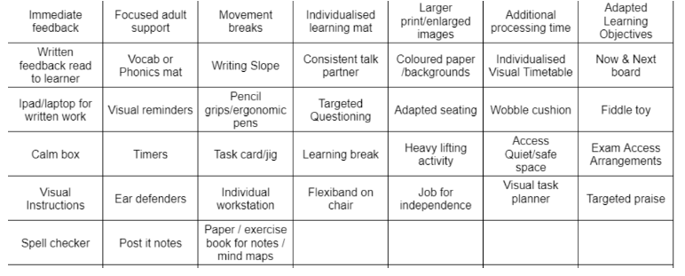

We deploy targeted intervention where needed to support not only academic needs, but social, emotions , mental health and communication needs (Wave 2 provision). We include interventions such as:

Focus and Attention:
● Bucket Time
Learning behaviours
● Ready to learn
Subject specific
● Precision teaching
● Reading: additional phonics, 1:1 reading (bottom 20% readers), high
frequency words
● Writing: pre-teaching
● Spelling: additional phonics, High Frequency Word, pre-teaching
Speech & Language
● Speech link
● Language link
● Pre-teaching vocab
● Active Listening
Language
● Colourful semantics (sentence structure)
Social communication
● Talkabout
● Active listening
Emotional regulation
● Zones of Regulation
● Weekly check ins
Sensory regulation and physical needs
● Sensory circuits
● Jump Ahead
Where needed, we utilise support and guidance from
outside services such as speech and language therapists, TASS (Attendance and Inclusion) and CLASS, Education Psychologists and occupational therapists to deploy specialised, enhanced support for those learners who require more specific provision.

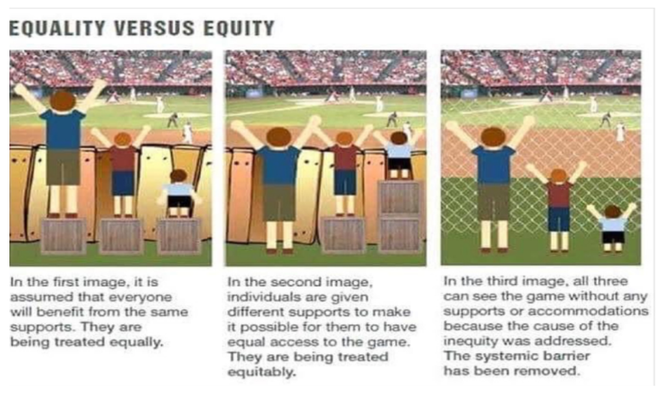
9. How are pupils/young people with SEND included in activities with other
children, including school trips?
(SEND CoP 6.79 bullet 11)

Through careful planning and reasonable adjustments, children with SEND engage in the activities of the school together with those who do not have SEND and are encouraged to participate fully in the life of the school and in any wider community activity.

We work with parents and children to listen to their views, feelings and wishes to ensure children with SEND engage fully in the life of the school and in any wider community activity. All children have access to social narratives and check-ins ahead of school trips and activity days.

The class teacher in consultation with the parents will plan ahead for any off site trip or activity to ensure that their child will be able to access wider curriculum activities safely and fully. Similarly, school staff will liaise with parents about how children with SEND can take part in after school clubs which will involve a variety of activities, including physical exercise. Visits and risk assessments are arranged by teaching staff beforehand and specific arrangements for SEND learners are discussed and accounted for during this process. If a learner chooses not to attend a trip, alternative arrangements will be made for their time in school.

We also make adjustments for social events by providing a breakout room and inviting parents/carers to bring children into school events earlier to make it a quieter and less busy environment. School trips

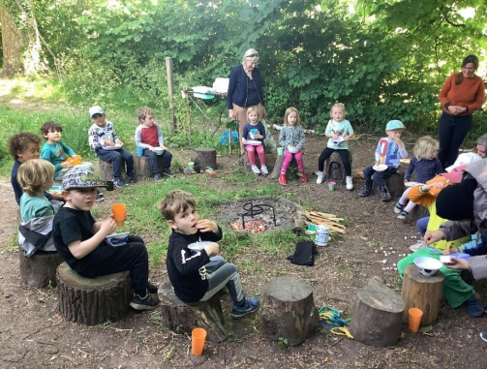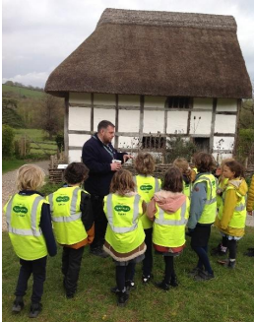

10. How do we involve parents and carers involved in reviewing children’s / young people’s progress and planning support?

At Western Road, we encourage parents and carers to have as much involvement in reviewing their child`s progress as possible. Children with SEND’s progress support is documented in a variety of formats, focusing on a graduated approach, and depending on their level of need, but they will have a review meeting three times a year which will involve the school staff, parents and the SENDCO.

All children with SEND have an Additional Needs Pan with SMART Targets which are reviewed three times a year or more often as the need arises. Parents are fully informed through a meeting about any changes in their child`s provision. The Additional Needs Plans follow a process of Assess Plan Do Review. We assess where the child is at and what their specific needs are. We Plan for an outcome, the Do section explains how we will support the child and the Review section identifies whether the child has achieved the Plan.

For more information about this, please see the Parent Guide on the Graduated Approach on our school website.

Children with more complex needs may have an Education Health and Care Plan with Local Authority funding which will be reviewed annually. School staff, parents and outside agencies attend these annual reviews.

11. How are children involved in reviewing their progress and planning support?

Children with SEND at Western Road are invited, through pupil voice and other opportunities, see tables below, to contribute to the decisions that are made about their support in school. This is done through the child talking with a trusted adult such as the support staff, class teacher or SENDCO.

A `home-school` book or communication through email, is sometimes used to inform the staff about any concerns from home that may help them to understand the child`s response to their support on a daily basis.

The chart below shows the different opportunities children have to talk about their learning:
 | Who’s involved? | How often?
Self-assessment | Child, class teacher | Daily
Class Circle times | Child, class teacher | Weekly or as needs arise
Questions / Worry box | Child, class teacher | Weekly or as needs arise.
School Council | Class, class teacher, PSHE subject leader | Fortnightly
Pupil Voice | Child, SENDCo, class  teacher/ teaching assistant | At least once a year
Additional Needs Plan Targeted review meetings | Child, parents, class teacher supported by SENDCo | At least three times a year
Annual reviews (EHC Plans only) | Child, parents, SENDCO, class teacher, support services, local authority. | Once a year

12. What training do the staff have?
(SEND CoP 6.79 bullet 9)

When we plan support for a child, we think about the knowledge and skills their teachers and support staff will need. If necessary, we plan training for the staff member or arrange an INSET training day.

The Headteacher, in consultation with senior leaders, staff and governors, sets up the whole school development plan at the beginning of the year and this is reviewed throughout the academic period from September to July. This plan carefully matches the training needs of the staff with the targets and objectives set down in the document.

All our teachers are fully qualified and trained in accordance with the professional requirements of the DfE.

Our SENCo has completed the SEND qualification. Our support staff receive training to deliver literacy, speech and language, numeracy, social skills, nurture, jump ahead and sensory circuit interventions. Lunchtime assistants are trained in supporting children with play skills and other specialist staff include a play and art therapist.

We have a wide range of training available to us which is mainly provided by outside agencies such as the Communication, Learning and Autism Support Service (CLASS) and the Speech and Language Service. We also provide INSET for staff using the expertise from within the school community.

13. How does the school measure how well it teaches and supports children with SEND?
(SEND CoP 6.79 bullet 10)

We regularly and carefully review the quality of teaching for all children to make sure no-one under achieves. We look at whether our teaching and programmes of support have made a difference. We use information systems to monitor the progress and development of all children. This helps us to develop the use of interventions that are effective and to remove those that are less so.

We complete an annual self-evaluation of our SEND provision and use this to develop an action plan to further improve our SEND provision.

We invite parents to provide feedback at meetings, through attending parent forums and through the Ofsted parent view website.
https://parentview.ofsted.gov.uk/

14. How accessible is our school and how does the school arrange equipment or facilities children need?
(Section 69 Children and Families Act 2014)

At Western Road we make reasonable adjustments and provide auxiliary aids to our premises in accordance with the Equalities Act to help all children with SEND who require access to the school building. We have set out our policy regarding this in our Equalities and Accessibility Plans.

For more information see our Equality Policy, Equality Action Plan and our Policy on Supporting Pupils with Medical Conditions on our school website.

15. What support is there for children’s/young people’s overall well-being and their emotional, mental, and social development?
(SEND CoP 6.79 bullet 12)

We know that it is extremely important for every child’s mental and emotional well-being to be supported and monitored at school. Children with SEND are especially vulnerable in this aspect of life at school. Without careful monitoring and planning for their support in this area they will fail to thrive and make progress and feel that they are included in the life of the school.

Through school assemblies and class based programmes such as Emotional Regulation work and intervention work using Circle Time activities, we support children as part of the school community and as individuals.

We can also offer individual therapeutic work and some group nurture work for those who are particularly vulnerable.

We will monitor and review progress, with the child and parent, so that we can see good outcomes for them. We will do this as part of the SEND support planning cycle of assess, plan, do, review.

The school may work with other services to support children, e.g. CLASS, TASS CAMHS, Early Help services, Family Support Workers etc.

16. What specialist services do we work with to support children and their families?
(SEND CoP 6.79 bullet 13)

As part of the cycle of SEND support we will consider carefully whether we need to involve other services to make sure the child’s specific needs are met. Parents are always involved in any decision to involve specialists.

We work with:
- Health Visitors
- Occupational therapist
- Physiotherapists
- Early Help Key Worker
- Social services
- Early Years Service
- Team Around the School and Setting (TASS) - Inclusion and Attendance
- Communication Language Autism Support Service (CLASS)
- English as an Additional Language Service (EALS)
- Educational Psychology Service (EP)
- Children and Adolescent Mental Health Service (CAMHS)
- Speech and Language Therapy Service (SALT)
- Placement Support Service (PSS)
- School Health Service
- Open for Parents parenting service

17. Where can I get information and support?
(CoP 6.81 re local offer)

The East Sussex Local Offer, which outlines support for SEND pupils, is
available at https://www.eastsussex.gov.uk/childrenandfamilies/specialneeds/localoffer/

Amaze SENDIASS is the Special Educational Needs and Disability Information,
Advice and Support Service for East Sussex and Brighton and Hove. If you are
a child or young person with a special educational need or a disability (SEND), or the parent of a child or young person with SEND, you can turn to Amaze SENDIASS for information and advice.
https://amazesussex.org.uk

CITES are a team of qualified occupational therapists, physiotherapists, speech and language therapists, assistants and administrators who provide
non-acute therapy to children and young people living in East Sussex.
Visit CITES at:
https://www.eastsussexchildren.nhs.uk/about/childrens-integrated-therapy-services/

East Sussex Wheelchair Service provides assessments for adults and children
with mobility and postural problems. They supply manual and electric powered wheelchairs, buggies, pressure relieving cushions and accessories such as backrests, foot rests and arm rests for wheelchairs.
Visit the East Sussex Wheelchair Service at:
https://millbrookhealthcare.co.uk/pages/east-sussex-wcs

East Sussex Customer Service for Children’s Services
Email: informationforfamilies@eastsussex.gov.uk

CLASS+ works across East Sussex to support families/carers of Autistic
children and young people. Their aim is to provide guidance and training that enables families/carers to build their understanding of the strengths and challenges faced by Autistic children and young people and to develop greater confidence in how to support them.
Find out more information about CLASS+ at:
https://1space.eastsussex.gov.uk/Services/4848

i-go is the East Sussex Children and Young People’s Additional Needs Register
and free leisure discount card. The card is available for those aged 0-25 with
additional needs living or studying in East Sussex. This could include physical,
learning, social, emotional, and mental health needs.

Visit i-go at: https://igo.eastsussex.gov.uk/

18. What should I do if I’m not happy?
(SEND CoP 6.79 bullet 14)
If you have any concerns, please contact your child’s teacher. If you would like further advice please contact the Head Teacher to arrange a meeting. If you feel your concerns are not satisfactorily resolved, please see the schools Complaints Policy which is available on the school website, or from the school office.

