 | 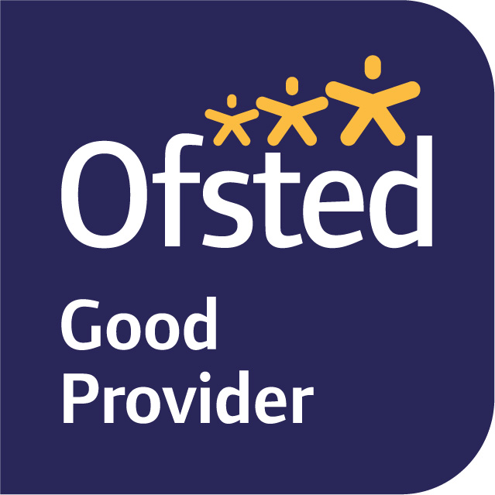

September 2025

Dear Parents and Carers,

Welcome to Year 3! It has been lovely to see the children again and they have transitioned well in to KS2.

Learning journey
Our first learning journey in Year Three is ‘The UK’ with our focus question being, ‘What do maps tell us about the UK?’ This is a geography focused topic all about the country we live in and everything around us. We will be thinking ‘what can I learn from a map?’ and learning how to read, follow and design maps. We will also be exploring the essential skills of a map maker, including compass skills, understanding of direction, coordinates and scale.

This will link with our work in English, where we will be exploring a range of focus texts linked to journeys. We will be starting with the book, ‘Journey’, where we will review the components of a narrative story, enrich our sentence structure by using conjunctions and interesting descriptive language that captures ones imagination. These lessons will lead onto writing a narrative story about their own creative journey. We will also have weekly spellings where we will explore different ways in class to remember the spellings. We will also continue to do some phonics lessons, using the Sounds Write program started in Key Stage 1 last year.

Foundation subjects
For science this term our topic is Forces. This will include investigating how magnets work, thinking about compasses and conducting experiments which test out different forces such as gravity, air resistance and water resistance and come to conclusions how friction can affect the speed of an object. Our art this term will focus on two elements of art: line and colour. We will look at the works of British artists, Eric Ravilious and David Hockney in how they use these elements and develop various techniques to create images inspired by Ravilious’s and Hockney’s work. In PSHE we will be reminding ourselves of the Zones of Regulation and exploring our emotions and building toolkits to support our emotions. We will continue in positive friendships and interactions. We have PE and forest school on Wednesdays so your child will either come in to school in clothes suitable for forest school or their PE kit (please see separate email from Katie). In Music we will find the rhythm and pulse of various genres of music and play the glockenspiels. In French we will begin learning basic saying and how to respond to them. RE will focus on Christianity for two terms. We will be using resources provided by the scheme ‘Understanding Christianity’ to explore two question: ‘What do Christians learn from the Creation story? and What is it like for someone to follow God?’ In Computing we will learn about E-Safety, how to use a laptop to go on the internet to access Times Table Rock Stars. We will also be using a blend of iPads and laptops to begin coding using Sparks Academy.

Maths
In Maths we have started the term by looking at place value. We will explore 3 digit numbers by looking at the place value of each digit and then using this knowledge to compare different numbers. Later in the term we will also look at addition and subtraction of numbers up to 1000 by using a range of strategies for calculating addition and subtraction problems. They will need to be able to explain how they have solved problems, especially when using mental maths.

Reading
Your child will be read with in a variety of ways; whole class reading, small group reading and 1:1 depending on the format of our guided reading sessions for the week. Your child will be sent home with a sounds write reading book, a library book and a reading record every week. The sounds write books will carry on from where they left off in Year 2, some children will have finished these so will be just be bringing home library books. These are for practising the sounds we have learnt in class and should be read alongside other books at home for enjoyment. All children are welcome to bring in books from home to keep in their tray to read throughout the week. Please do encourage your child to read to you every day even it is just a couple of pages and record this in their book or they are able to record it if they want to.

Trays
The children now have trays in the classroom in order to develop their independence. They are allowed to bring in a pencil case from home (which fits in their tray!) with their own pens, pencils, rubber, sharpener etc. They are also able to bring in a book from home and will keep their snacks here. Additionally, they have been given a ‘busy book’ which they can access throughout the day and we will be teaching them ways they can use this e.g journaling.

Please do either come and see me at the green gate or email the office if you have any queries or concerns about your child or anything that is happening at school and they will pass on the information to me. I am looking forward to another year with this lovely class!

Kind regards,
Mrs Green

