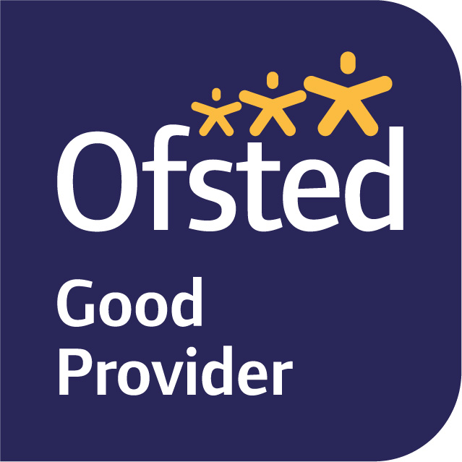

5th^{th} September 2022
Dear Parents and Carers,

Welcome to Year 6!

Our first learning journey in Year Six is ‘The Groovy Greeks’, focusing on aspects of Ancient Greek life and making comparisons between past and present day Greece, as well as researching and investigating the Olympic Games.

In English, we will be focusing on linking our topic (Groovy Greeks) through a series of short tales based on Greek Myths (The Orchard book of Greek Myths). We will be writing first person entries from the point of view of different characters and as a class we will be researching and writing non-fiction based upon the Greek Olympic games. We have already started the topic by hosting a fantastic “Ancient Greek Day” which was wonderfully fun and enjoyable for all. What a fantastic start to the year! We will also continue to develop our knowledge and understanding of grammar, punctuation and spelling (GPS) which will be extremely important during Year 6 and for SATS. During our Guided Reading sessions, we will be developing the children’s inference and deduction skills through whole class reading.

In Maths, we will focus upon number, revisiting place value and the four operations (addition, subtraction, multiplication and division). This enables the children to take part in whole-class activities and discussions about different aspects of number.

In Science, we will be learning about The Circulatory System which we are linking to our PE sessions and being a “Greek Olympic athlete”. In our Art lessons, we will be making links to our Ancient Greek topic and will be focusing on observational drawings on the hands.

PE is on Monday and Friday this term. Please ensure your child is wearing their full named PE kits to school on those days (including trainers or plimsolls). If your child has pierced ears, please can they either not wear their earrings to school on the days of P.E or be able to take them out as we are unable to allow the children to wear any jewellery. Newly pierced ears can be taped at home on these days as long as you let me know. If your child is unable to do PE for any reason, please inform me in writing or tell us personally.

Homework will be set on Fridays to be completed by the following Tuesday. It will usually be an online My Maths task, spellings to learn, and a small written homework linked to our English and Topic learning for the term. Homework will be completed via SeeSaw / MyMaths unless otherwise stated.

If you have any queries, please do not hesitate to see me.

Yours sincerely,
Miss N Knight
Year Six Class Teacher.

