 |  | Western Road Community Primary School Weekly Maths Plan
 |  | Class: Oak |  | Teacher: R Hamilton |  | Term: Four 2020 | Week Beginning: 23.3.20
Topic: Composition and Calculation: Numbers to 10,000,000
 | Mental Starter/ Revision |  | Introduction |  | Core Group Extension Group Support Group |  |  | Plenary / Assessment / Next Steps
Monday | Practise the times table that is your weakest |  | WALT: Use arithmetic skills to solve problems. |  | All groups – timed arithmetic challenge. Try to do all 36 questions in 30 mins. |  |  | Mark your work and see how you did. Work on anything that you found tricky.
Tuesday | KenKen Puzzles |  | WALT: find a rule to solve one-step algebra equations  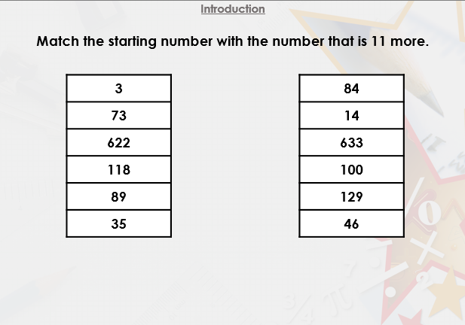  See Slide one of presentation |  | Varied Fluency  Go through this first: Challenge B Model solving similar tasks using presentation – varied fluency 1-4  Challenge B – Questions 5A-8A  Challenge A – Questions 1A-4A – they are similar in structure but with less complex values.  Challenge C – 9A-12A  Problem Solving (Star Challenge)  Go through this first: Star Challenge B Model solving these reasoning chllenges using presentation. Chn make notes as needed and solve problems as a class.  Challenge B – Questions 4A-6A  Challenge A – Questions 1A-3A – they are similar in structure but with less complex values.  Challenge C – 7A-9A |  |  | Discuss findings and misconceptions.  Adults to give feedback/mark work as appropriate.
Wednesday | Revise questions from yesterday. |  | WALT find a rule to solveo 2 step algebra problems  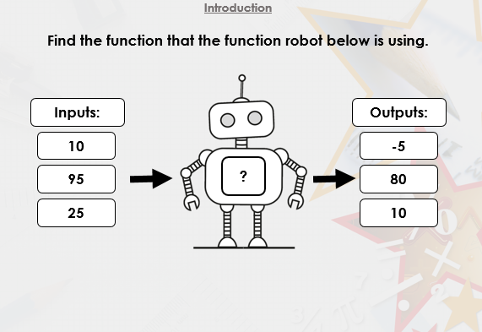  See Slide one of presentation |  | Varied Fluency  Go through this first: Challenge B Model solving similar tasks using presentation – varied fluency 1-4  Challenge B – Questions 5A-8A  Challenge A – Questions 1A-4A – they are similar in structure but with less complex values.  Challenge C – 9A-12A  Reasoning and Problem Solving (Star Challenges)  Go through this first: Star Challenge B Model solving these reasoning chllenges using presentation. Chn make notes as needed and solve problems as a class.  Challenge B – Questions 4A-6A  Challenge A – Questions 1A-3A – they are similar in structure but with less complex values.  Challenge C – 7A-9A |  |  | Discuss findings and misconceptions.  Adults to give feedback/mark work as appropriate.
Thursday | Revise questions from yesterday. |  | WALT form expressions  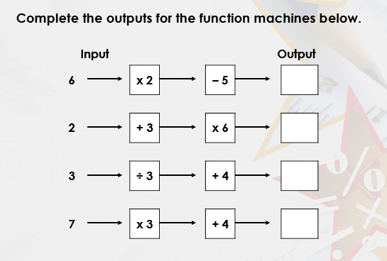  See Slide one of presentation |  | Varied Fluency  Go through this first: Challenge B Model solving similar tasks using presentation – varied fluency 1-4  Challenge B – Questions 5A-8A  Challenge A – Questions 1A-4A – they are similar in structure but with less complex values.  Challenge C – 9A-12A  Reasoning and Problem Solving (Star Challenges)  Go through this first: Star Challenge B Model solving these reasoning chllenges using presentation. Chn make notes as needed and solve problems as a class.  Challenge B – Questions 4A-6A  Challenge A – Questions 1A-3A – they are similar in structure but with less complex values.  Challenge C – 7A-9A |  |  | Discuss findings and misconceptions.  Adults to give feedback/mark work as appropriate.
Friday | Revise questions from yesterday. |  | WALT substitute values  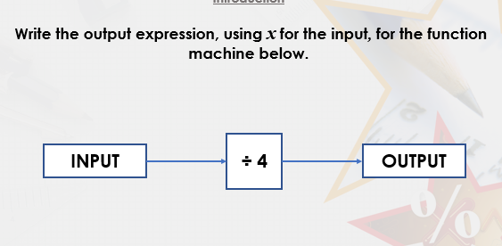 |  | Varied Fluency  Go through this first: Challenge B Model solving similar tasks using presentation – varied fluency 1-4  Challenge B – Questions 5A-8A  Challenge A – Questions 1A-4A – they are similar in structure but with less complex values.  Challenge C – 9A-12A  Reasoning and Problem Solving (Star Challenges)  Go through this first: Star Challenge B Model solving these reasoning chllenges using presentation. Chn make notes as needed and solve problems as a class.  Challenge B – Questions 4A-6A  Challenge A – Questions 1A-3A – they are similar in structure but with less complex values.  Challenge C – 7A-9A |  |  | Address areas of misconception. Identify areas to review tomorrow.

