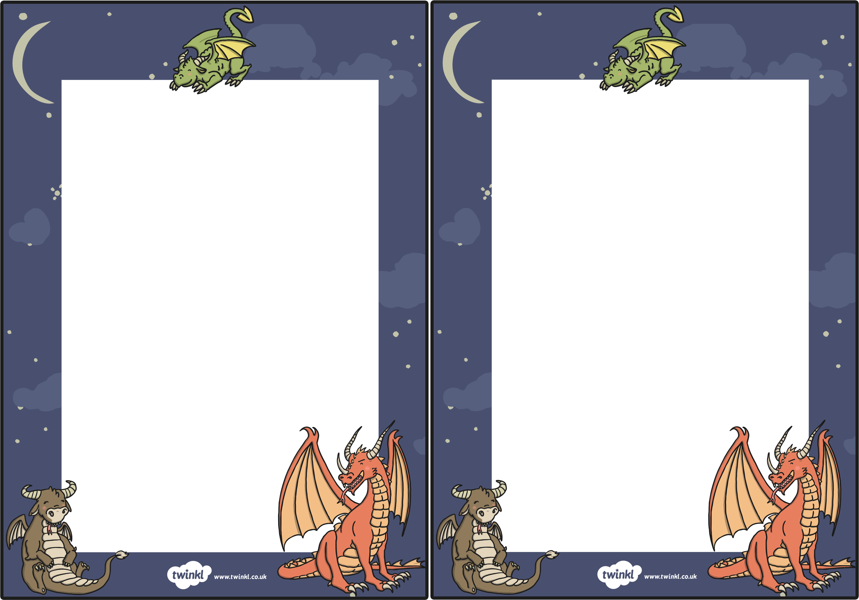
TEXT HERE
To…………
Please can I come to visit you one day, I am very lonely!
Love Dragon.

