Western Road Community Primary School Weekly Maths Plan
Class: Willow (Year 4) Teacher: Mrs Bracher Term: 5 Week Beginning: 04.05.20 Wk 3
 | Starter |  | Introduction/ Main | Challenge
Monday | 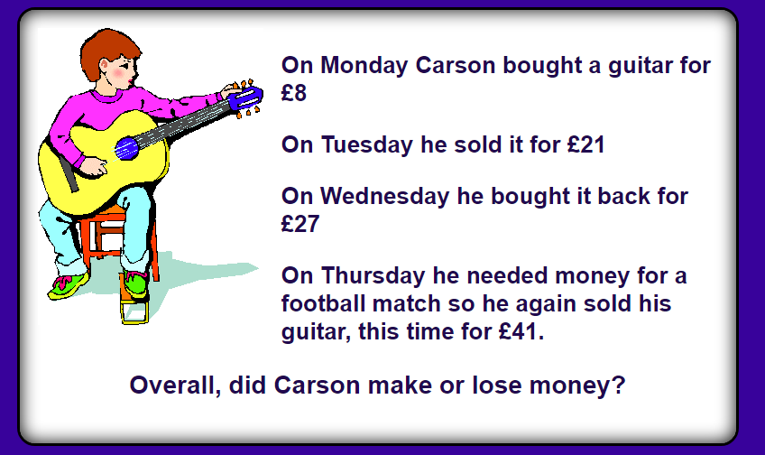 |  | WALT: estimate money  We are carrying on looking at money today and thinking about how we can estimate how much money we would be spending on different things. Today’s activity will look at rounding as a way of estimating money.  Have a look at today’s worksheet, remember that you only need to do one page walk (page 1) jog (page 2) or run (page 3) | Have a look at today’s challenge.  Can you work out who bought which toy?  What would you buy with £30?
Tuesday | Can you create a pop up shop with a few items at home? Make sure they have price labels on.  What could I buy from your shop with £5? |  | WALT: estimate money  We are still looking at estimating money again today. You should have got the hang of how to round numbers to the nearest 10 now. We are simply using the same technique but with money.  Have a look at today’s worksheet, there isn’t a choice of pages today but the questions get trickier as you go along so don’t be disheartened if challenge 1 is too easy for you. | Have a look at today’s challenge.  How many different variations can you create of amounts that would round to £4 + £5 = £9? For example it could have been £3.99 + £5.10
Wednesday | Today’s starter is all about the number 77. Can you find 5 different mulitplicaiton questions where the answer is 77? |  | WALT: use the four operations  In maths today we are going to looking at solving some different money problems but these problems will involve looking at all four operations (plus, minus, multiply, divide)  Choose which level of challenge you want to do today walk (page 1) jog (page 2) or run (page 3) and have a go at working out the money problems. Each question is about the fruit at the greengrocers which is priced at the top. | Have a look at today’s challenge.  There are 3 different deals from the shops. Can you spot something wrong with them? Can you explain to the shop keeper why they are rubbish deals?
Thursday | Can you find any prices on anything at home? (if you are struggling – look at books! They usually have RRP and then the price)  Create a receipt for all your items that you have found. |  | WALT: use the four operations  We are still looking at using the four different operations today as a way of calculating amounts of money. Today we will be thinking more about explaining how we know an answer. Make sure that on the sheet today you are answering the questions at the bottom which will challenge you further.  Remember that you only need to do one page, think about what level of challenge you feel is right for you today. | Have a look at today’s challenge.  Can you complete Dora’s receipt using the clues?
Friday |  |  | No maths due to bank holiday. If you want to do some maths today you could have a go at TT rockstars.

