Western Road Community Primary School Weekly Maths Plan
Class: Willow (Year 4) Teacher: Miss Sheppard Term: 4 Week Beginning: 23.03.2020 Week 5
 | Starter |  | Introduction/ Main | Challenge
Monday | Practise 3 times tables. |  | WALT  Recognise tenths and hundredths using a hundred square.  Look at the Hundred Square (in resources).  How many rows are there? How many columns?  Each square is one-hundredth (1/100). Each row is one-tenth (1/10) or 10-hundredths (10/100). That means 1/10=10/100 – one-tenth equals ten-hundredths. Complete the table (Recognising Tenths and Hundredths), using a hundred Square to support. | 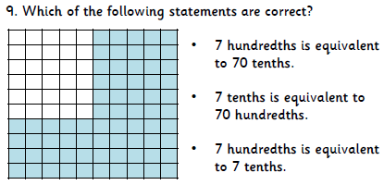
Tuesday | Practise 4 times tables. |  | WALT  Recognise and write tenths and hundredths as decimals and fractions.  Work through the Tenths and Hundredths PowerPoint.  Have a go at matching the pairs (Pair Cards) and then work on the Match It activity. | 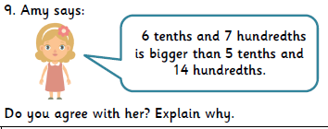
Wednesday | Practise 6 times tables. |  | WALT  Read and represent tenths on a place value grid.  If we have the number 1.5, that means we have 1 whole and 5 tenths. How would this be shown on a place value grid?  Have a go at placing various tenths fractions on a place value grid. Include improper fractions (fractions where the numerator (top number) is larger than the denominator (bottom number) e.g. 16/10 = 1 whole and 6 tenths = 1.6) | 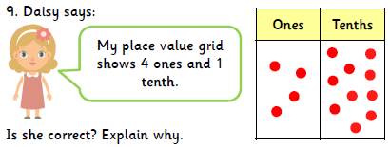
Thursday | Practise 7 times tables. |  | WALT  Divide 1 and 2 digits by 10.  Work through the PowerPoint (Dividing by 10).  Have a go at the Dividing by 10 Maze Activity. | 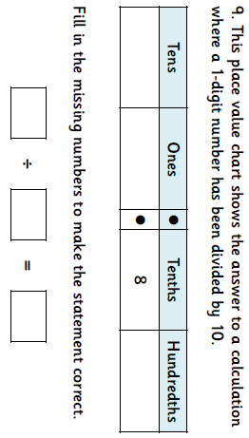
Friday | Practise 8 times tables. |  | WALT  Divide 1 and 2 digits by 100.  Work through the PowerPoint (Dividing by 100).  Have a go at the activities on the presentation.  Complete the Pixie Measuring Sheet | 