Fun with Rolling Eggs (You do not have to use eggs but could do your own experiment with a chosen round object. The experiment is to find out which material helps your egg or object go faster down a ramp or slows it down.) Have Fun.

Hardboiled Eggs | Bubble wrap | Kitchen towel | Stopwatch/Timer | Ramp/slide
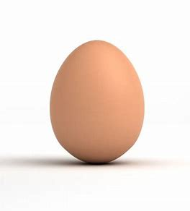 | 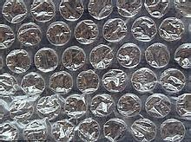 | 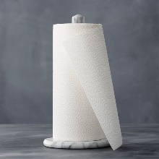 | 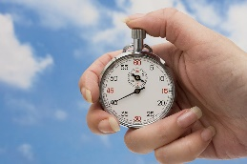 | 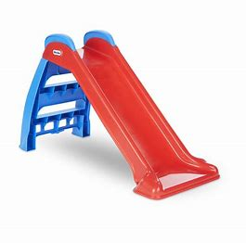
Instructions
- Decide on two markers on your ramp which you will use to time the amount of time the egg takes to travel down the ramp.
- Place the egg at the top marker and let it roll down to the second marker stop the timer when it gets to the second marker and record the result.
- Repeat 3 times recording your results each time.
- Wrap your egg in bubble wrap and repeat steps 3 and 4.
- Wrap your egg in kitchen towel and repeat steps 3 and 4.

The Science Bit
Can you think of other items you can wrap around your egg? What do you think slows down or speeds up the egg? Did any of the eggs break? Which material protected the egg best?

Can you make a parachute to protect the egg when it falls?

