Rainforests

ENQUIRY QUESTION
How does life in temperate Lewes compare with the tropical rainforest?
Key questions to ask yourself:
- What are the impacts of deforestation?
- What is the climate like in the rainforest?
- Which animals and plants are found in the rainforest?
- Where in the world is the rainforest?

Key facts:
- 5.5 million square km
(previously covered a
much larger area)
- Parts in Brazil, Peru,
Colombia, Venezuela,
Ecuador, Bolivia,
Guyana, Suriname
and French Guiana
- 2.5 million insect species
- 40 000+ plant species
- 3 000 edible fruits
- 2 000+ species of birds and mammals
- 2 million tourists per year
- 170 different languages spoken
- 250 000 native tribes currently live there
Language of a Geographer

climate | The average weather conditions over a long period of time
deforestation | The cutting down and clearing of forests.
equator | An imaginary circle running round the centre of the earth.
humid | Feeling very damp due to water vapour in the air.
native tribes | The original settlers of an area.
species | A group of similar animals or plants
weather | The specific condition on a given day

Rainforests are found near to the equator between the tropic of Cancer and the tropic of Capricorn They can be found in every continent except Antarctica.
They are located in countries such as Brazil,
India, Peru, Mexico, Australia and Malaysia.
Where in The World?

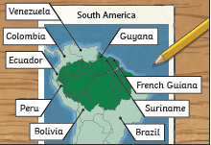
What are the layers in the rainforest?

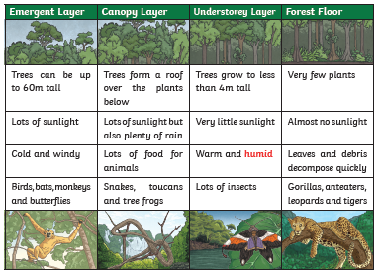
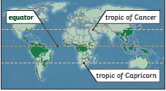

“He who plants a tree loves others beside himself.”
(English Proverb)
The climate in the rainforest is the same all year round.
• Average rainfall of
6cm each month
• Usually rains every day
• Hot and humid

