HOME PACK
As Year 1 is such a demanding year I have put together a pack of ways you can help your child at home if you wish. I hope you find it useful!
Phonics
Phonics is the most important part of Year 1 learning. It will enable children to read and write more fluently. Attached are the different phonic sounds. You can use these as a basis for phonics learning. For instance, make flash cards with them, see how many they can name in one minute, hide them around the house to find, use them to make a car park game, play noughts and crosses, pick a sound and go on a sound hunt by seeing how many things you can find in the house with that sound, come out with real and fake words using the sounds and see if they can sort them into trash and treasure, use them as stepping stones to jump on and sound out.
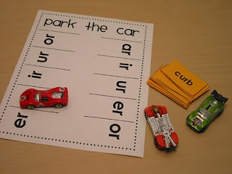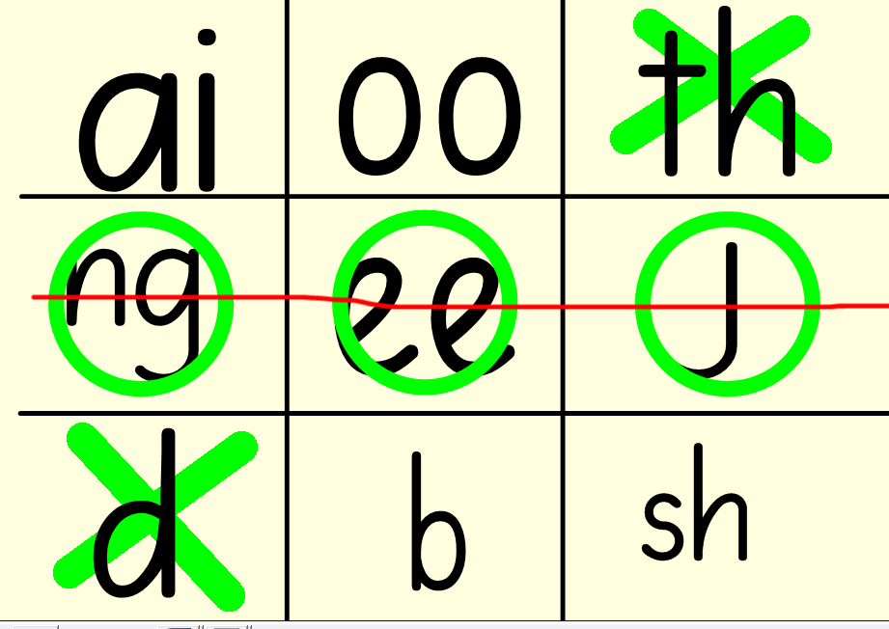
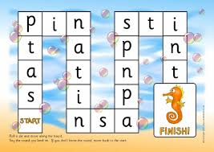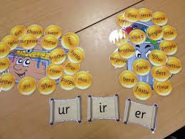
Websites –
letters and sounds
phonics play
YouTube – Geraldine the giraffe
There are also apps for phones and tablets
Writing
If you choose to boost your child’s writing by practising at home here are some ideas; diary entries, making or retelling stories, writing instructions (e.g. for making a cake), writing poems and researching and writing facts about whatever your child is interested in. In Year one we focus on them using capital letters, full stops, spelling, handwriting, description and conjunctions.
Handwriting is a big focus that I would like the children to develop. We use the cursive font which can be found online or I have attached a handwriting sheet your child can practise from.
Maths
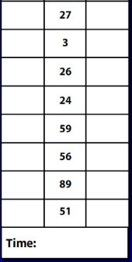
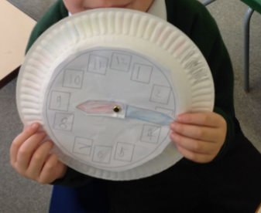
Maths in Year 1 is all taught practically! We focus on counting (in ones, twos, fives and tens), recalling one more and one less to 100, adding, subtracting, using mathematical signs like - + = to make number sentences, 2d and 3d shape, o’clock and half past, writing the numbers correctly and measure, such as length, weight and time. I have attached some Numicon sheets to help you practise these things at home but you can use anything you find around the house (toys, spoons, pencils), go on a 2D shape hunt or make shapes with pencils, weighing ingredients for a cake, practise telling them time by making your own clock. I would personally focus on counting and number bonds to 10.
For a challenge:
2 + __ = 5
___ - 6 = 4

