April 2023

Dear Parents and Carers,

Welcome back to Term 5! Our learning journey for this term is ‘Into the Woods’. We will be exploring this topic throughout all of our subjects.

Literacy and maths
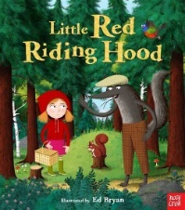
In Literacy we are focussing on the well-known fairy tale ‘Little Red Riding Hood’. The children have been acting as detectives to investigate a crime scene that was found in the classroom and will be writing up reports and conducting interviews with the characters. They will be writing diary entries as the wolf, rewriting their own versions of the story and we will also be looking in to recipes and instructions to fill Red’s basket with delicious treats!

We will be learning about fractions in maths and then will move on to time in our main sessions. Alongside this we will be ensuring that the children are secure in the knowledge and skills we have covered in maths throughout the year getting ready for our SATs at the end of term.

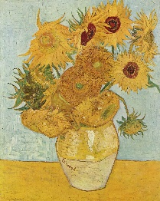
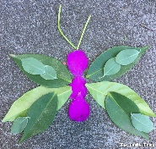
Foundation subjects
In Geography we will be exploring maps and creating our own for Red to follow in to the woods. We will also be focussing on man-made and physical features of the world and the different types of land we have in the UK e.g fields, beaches, woodland, cities. This leads nicely in to our science topic for term which is plants. We will be identifying and planting our own plants and conducting experiments to test what plants really need in order to survive in different places. In art we will be looking at famous paintings of flowers and recreating our own as well as making our own natural art outside. We are focussing on observing, sketching and painting skills this term.

Our PE days are Wednesdays and Fridays. Please could your child come in to school wearing their PE kits on these days.

TRIP
We have our trip to Wakehurst on Wednesday 3rd May. Please check your email to give permission for your child to attend as soon as possible. I would like to say a massive thank you to everyone who offered their help for the trip. We were overwhelmed with the amount of parents who could help! Unfortunately we can’t take everyone and I have contacted the parents who are coming this time round. This will change for our next trip.

I am looking forward to a fun, sunny term!
Kind regards,
Miss Blackwell

