Home learning tasks- guide for grown ups- 13.7.20
Please DO NOT feel like you have to do all of these tasks every day. Some days you might do all of them and some days you may not do any. These are just some ideas to keep you going for when your child ready and happy to learn.
Please do post your child’s work on Tapestry. We can comment on your child’s work and give them feedback. It’s a great way for us to interact with each other. If you have forgotten your password/ need help logging in, please contact us via email through Mrs Wooler at head@westernroad.e-sussex.sch.uk
Reading/Writing/ Phonics

Discuss with your child how after the summer holidays they are going to be going to Year 1 with Mrs Bishop, Mrs Adams and Mrs Johnson. Can they draw a picture of themselves and write around their picture things they would like to learn about in Year 1 or what they would like to get better at?

Phonics
https://www.youtube.com/watch?v=ALyrYqxhwiI Tricky words and decodable words for the children to learn to read and then write.

Continue to get your child to read with you as much as possible. You can create an account on the Oxford Owl website and access lots of free ebooks. We would have been reading book bands 1,2,3 mostly at school. https://home.oxfordowl.co.uk/books/free-ebooks/

Maths
https://whiterosemaths.com/homelearning/early-years/
Look at the link above and do 1 activity per day from summer term week 12

Understanding the world/ Expressive Art and design/ Communication and Language

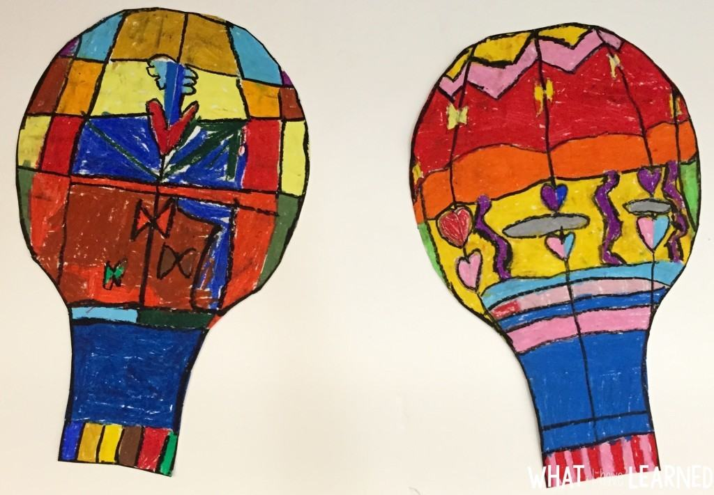
Cut out hot air balloon shapes and then draw using a black pen or pencil shapes on your paper. Next colour in your shapes to create a very colourful hot air balloon. Can you create patterns on your hot air balloon?

