February 2023

Dear Parents and Carers,
In Cherry Class we have already started our learning on our brand new topic. We started off with a flight to a mystery country and had to try and guess from a series of clues about what country we will be learning about. When we finally landed it was revealed that our new topic is…. Interesting India!
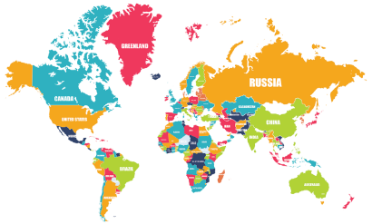
Throughout the term there will be a lot of thinking like a geographer! We will be using maps to find the UK and India. We will also be looking in to the human and physical features of both countries and comparing them.

In science, we are focussing on animals including humans and their basic needs for survival as well as life cycles and food chains.

We will be creating many pieces of bright, patterned art work this term starting with some mehndi designs and then moving on to rangoli patterns and shadow puppets.

In music, we will be exploring music from around the world and will look at the different types of instruments that are used.

In Maths, we have started with division and will then move on to fractions and properties of shapes. If you would like a deeper understanding of how this will be taught in lessons please have a look at the videos on this link. https://whiterosemaths.com/homelearning?year=year-2
You do not have to work through these with your child however they are useful for your own understanding of the vocabulary and process we use for teaching them.

In English, we are focussing on the story ‘Chapatti Moon’ which follows a similar pattern to ‘The Gingerbread Man’. The children will eventually end up with their own original stories based on this structure. We will also be looking at the traditional Indian folk tale ‘The Tiger Child’ and the story of ‘Rama and Sita’.

PE this term is on Tuesdays and Thursdays. Our first PE sessions will be yoga and our second PE session will usually be outside where we will be continuing our tennis skills so make sure you have a jumper on Thursdays!

Kind regards,
Miss Blackwell
Year Two Class Teacher

