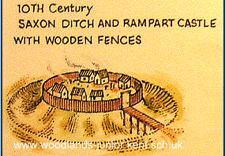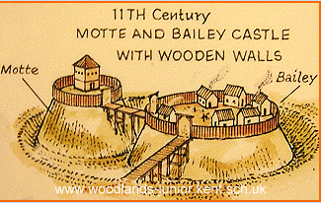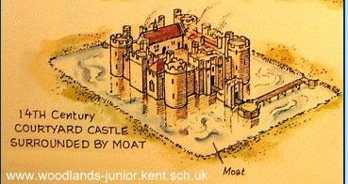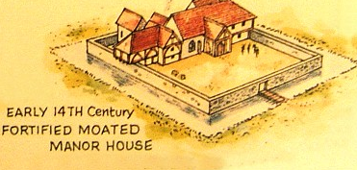
Who lives in a castle and why?
Castles and Dragons

Overview
This term we will be recalling all the historical events and people we have learnt about through the year. We will be creating a chronological timeline of these events.

We will be using primary and secondary sources when looking closely at artefacts from castles and homes.

We will be locating places around the world, with the focus being on looking at the different types of castles and where they are located.

Language of a Geographer
Continents | One of many of the world's main continuous expanses of land.
Africa | The second-largest continent from North to South, Africa stretches about 8,000 kilometres (5,000miles). Africa has the world’s longest river, the Nile, and the largest hot desert, the Sahara.
South America | South America is connected to North America by the narrow strip of Panama. These two continents weren’t always connected; they came together only three million years ago. South America is the fourth-largest continent and extends from the sunny beaches of the Caribbean Sea to the cold waters near the Antarctic Circle.
North America | North America is the third-largest continent, the continent includes the enormous island of Greenland in the Northeast. The continent stretches halfway around the world, from Greenland to the Aleutians.
Europe | Europe, the sixth-largest continent, contains just seven percent of the world’s land. In total area, the continent of Europe is only slightly larger than the country of Canada.
Asia | Is the largest continent. It has more than 40 countries. Some are among the most-populated countries in the world, including China, India, and Indonesia. Sixty percent of the Earth’s population live in Asia.
Australia | In addition to being the smallest continent, Australia is the flattest and the second-driest, after Antarctica. The continent is sometimes called Oceania, to include the thousands of tiny islands of the Central Pacific and South Pacific.
Antarctica | Antarctica is the windiest, driest, and iciest place on Earth. Antarctica is larger than Europe or Australia, but unlike those continents, it has no permanent human population.
North South East West | The four main compass directions that are used to when talking about direction.
Human Features | Created and built by humans e.g. train stations, buildings, bridges, schools.
Physical Geography | Anything that is on land naturally, bodies of water and landforms e.g. rivers, cliffs, waterfalls, mountains.
Fun Facts
The average time it would have taken to build a castle is 10 years.

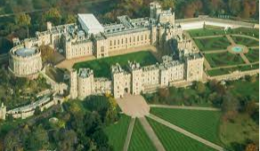
The biggest castle in England is Windsor Castle and is one of three homes of the Queen. It is said to be the largest inhabited castle in the world.

One of the largest castles in the world is in Poland. It is called Malbork Castle and was founded in 1274 but continued to be added to and grow in size to host the growing amount of knights that stayed there.
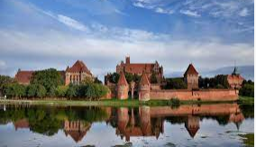

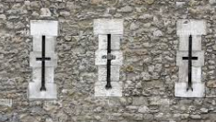
Arrow slits allowed a castle archer to shoot his arrows accurately from the castle’s walls while protecting him from enemy fire.

Language of a historian
Primary Sources | Primary sources are original first-hand accounts of an event, topic or historical time period
Secondary Sources | A secondary source is a second-hand account that interprets primary sources. They often use primary sources as the basis for their content.
Artefacts | An object that is made by a human, they can include tools, art and clothing
Chronology | The arrangement of events or dates in the order of their occurrence.
Lewes Castle | A Norman Castle built after the Battle of Hastings by supporters of William the Conqueror.
Normans | Were warriors and skilled leaders. They were most powerful under William, Duke of Normandy who led the conquest in 1066. They quickly changed England into a Norman country.
Key questions to ask yourself, activities you can do at home
What is my family history? Can I make a family tree?
Can you visit a different castle to Lewes and compare the two?
Can you draw a map of your journey to school?
Can you identify human and physical features on your map?

Key questions to ask yourself, activities you can do at home
What is my family history? Can I make a family tree?
Can you visit a different castle to Lewes and compare the two?
Can you do some research and find a castle in every continent?
Can you draw a map of your journey to school?
Can you identify human and physical features on your map?
Don’t forget to use google earth to find places and castles. http://earth.google.com/
Useful website are listed below:
https://www.english-heritage.org.uk/castles/life-in-a-castle/
https://www.english-heritage.org.uk/learn/histories/1066-and-the-norman-conquest/

Take Away Activity
On Tuesday 5th July we are going to have a Castle Day. On this day the children are invited to come dressed up as someone who has lived in a castle. This could be a king, queen, soldier, servant or a castle archer. On this day we would like the children to bring in a 3D castle they have made out of materials of their choice. It can be made from any construction materials of your choice however we ask that your child can carry it in independently. You can begin making your castles at any time but ask they only come to school on the 5th July. Your child might wish to add parts to their castle as we learn more about castles as the term progresses
Dates for your diary
23rd June 2022- Lewes Castle Trip
5th July 2022 Castle Day

