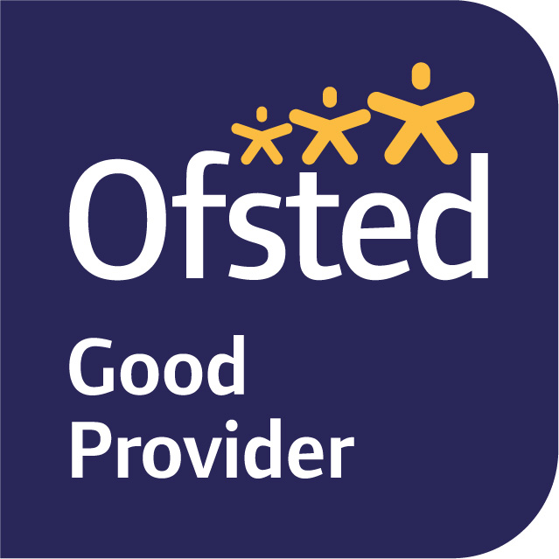

5th November, 2022
Dear Parents and Carers,

Welcome back to Term 2 and the lead up to Christmas!

Our current topic in Year Six is ‘The Victorians’, focusing on these key aspects: The monarchy, key inventors/ inventions, child poverty (the workhouses) and looking at Dr Bernardo and linking the current charity event: Children in need.

In English, we will be reading the book: Street Child by Berlie Doherty. This is a great classic novel about a Victorian orphan whose plight inspired Doctor Barnardo to set up his famous charity- linking nicely to our current topic. We will be writing a first-person account, a recount of an event and a narrative. During our guided reading sessions, we will be continuing to develop our retrieval, inference and deduction skills.

In Maths, we are mainly focusing on fractions this term, as well as square numbers, multiples and factors. Children should continue to use TTRockstars to practice their times tables, as these will help improve their pace during our maths lessons. We will be continuing to develop our reasoning skills, consistently asking the children to explain the method they have used, or provide evidence for their answer.

In Science, we will be learning about electricity- linking this into our Victorian topic- the birth of electricity. The key learning will be to compare and give reasons for variations in how components function, including the brightness of bulbs, the loudness of buzzers and to use recognised symbols when representing a simple circuit in a diagram.

PE is still on a Monday and Friday this term. Please ensure your child is wearing their full named PE kits to school on those days (including trainers or plimsolls). If your child has pierced ears, please can they either not wear their earrings to school on the days of P.E or be able to take them out as we are unable to allow the children to wear any jewellery. Newly pierced ears can be taped at home on these days as long as you let me know. If your child is unable to do PE for any reason, please inform me in writing or tell us personally.

Homework will continue to be set on Fridays to be completed by the following Tuesday. It will usually be an online My Maths task, spellings to learn, and a small written homework linked to our English and Topic learning for the term. Homework will be completed via SeeSaw / MyMaths unless otherwise stated.

If you have any queries, please do not hesitate to see us.

Yours sincerely,
Miss N Knight
Year Six Class Teacher.

