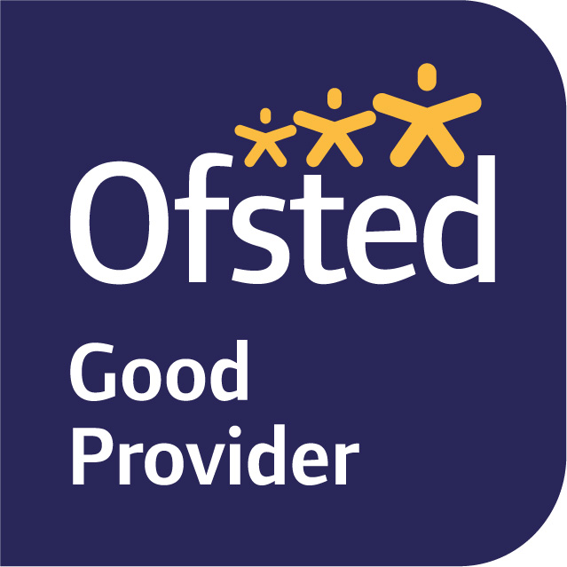

15th November 2021
Dear Parents and Carers,

Welcome back to Term 2 and the lead up to Christmas!

Our second learning journey in Year Six is ‘The Vikings’, focusing on our key Enquiry questions: How were women treated?, When and Why did the Vikings invade Britain?, What did the Vikings do for Britain? and Is it ever right to invade?

In English, we will be reading the book The Miraculous Journey of Edward Tulane by Kate Dicamillo. We will be writing: a character description of the main character, an informal letter and a biography of the main character’s life. This term we also have a strong focus on the key punctuation that must be learnt in Year 6, which is the colon, semicolon and dash. During our Guided Reading sessions, we will be continuing to develop our retrieval, inference and deduction skills.

In Maths, we are mainly focusing on Fractions this term, as well as square numbers, multiples and factors. Children should continue to use TTRockstars to practice their times tables, as these will help improve their pace during our maths lessons. We will be continuing to develop our reasoning skills, consistently asking the children to explain the method they have used, or provide evidence for their answer.

In Science, we will be learning about Evolution and Inheritance. Throughout the term, we will be looking at key terms such as: adaptive traits, variation and Natural selection. In our Art lessons, we will be designing, making and evaluating our very own Viking shield!

PE is still on a Tuesday and Friday this term. Please ensure your child is wearing their full named PE kits to school on those days (including trainers or plimsolls). If your child has pierced ears, please can they either not wear their earrings to school on the days of P.E or be able to take them out as we are unable to allow the children to wear any jewellery. Newly pierced ears can be taped at home on these days as long as you let me know. If your child is unable to do PE for any reason, please inform me in writing or tell us personally.

Homework will continue to be set on Fridays to be completed by the following Tuesday. It will usually be an online My Maths task, spellings to learn, and a small written homework linked to our English and Topic learning for the term. Homework will be completed via SeeSaw / MyMaths unless otherwise stated.

If you have any queries, please do not hesitate to see us.

Yours sincerely,
Miss T Fay
Miss N Knight
Year Six Class Teachers.

