Home learning tasks- guide for grown ups- 14.7.20
Please DO NOT feel like you have to do all of these tasks every day. Some days you might do all of them and some days you may not do any. These are just some ideas to keep you going for when your child ready and happy to learn.
Please do post your child’s work on Tapestry. We can comment on your child’s work and give them feedback. It’s a great way for us to interact with each other. If you have forgotten your password/ need help logging in, please contact us via email through Mrs Wooler at head@westernroad.e-sussex.sch.uk
Reading/Writing/ Phonics

Being thankful. Talk as a family about something or someone you would like to say thank you too. It could be anything – they helped you get ready, played a game with you, helped someone who was hurt, or made people laugh.
After your discussion can you make a thank you card to something or someone they are grateful for?

Phonics
See Tuesday phonics sheet- Read and match the words to the correct pictures.

Continue to get your child to read with you as much as possible. You can create an account on the Oxford Owl website and access lots of free ebooks. We would have been reading book bands 1,2,3 mostly at school. https://home.oxfordowl.co.uk/books/free-ebooks/

Maths
https://whiterosemaths.com/homelearning/early-years/
Look at the link above and do 1 activity per day from summer term week 12

Understanding the world/ Expressive Art and design/ Communication and Language

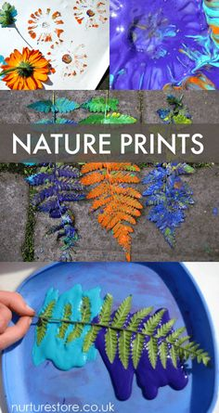
Go on a walk to your local park or a wonder around your garden. Find different shaped leaves and flowers and create some prints with them using paint.

