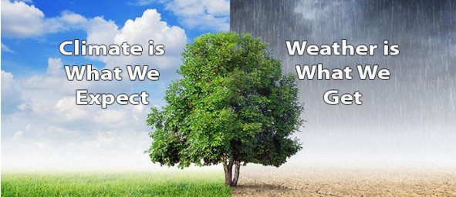
Extreme Weather

How does what’s outside impact on our lives now and in the future?

Key concepts:
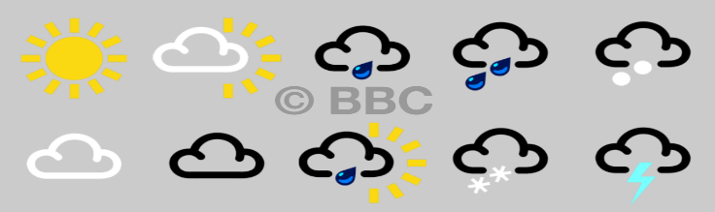
In a weather forecast, symbols are used to show what the weather will be like in a particular area. People check the weather forecast before they make plans for a day out.

Here are some tools to measure different types of weather:
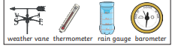

The impacts on some extreme weathers might have devastating effects on people’s lives. For example hurricanes and floods. Extreme weather can affect our surroundings as well as our lives.

Things to try at home:
Language of a Geographer
Weather | The day-to-day conditions of the atmosphere. Weather can change quickly. One day it can be dry and the next it may rain.
Climate | Average weather conditions over longer periods and over larger areas. It would take a long time for the typical climate of an area to change.
Temperature | How hot or cold something is, measured in Celsius or Fahrenheit.
Weather Forecast | A prediction of what the weather will be like in the future. This is done by looking at weather patterns.
Meteorologist | A scientists who observes, studies or forecasts the weather
Seasons | The year is divided into four seasons; spring, summer, autumn and winter.
Observations | What you notice when you look carefully at something
Record | Keeping information about something that has happened such as a measure of how much rain has fallen.
Extreme | Beyond what is expected as normal
Drought | When there is little or no rain over a long period of time.
Flooding | When usually dry land is covered with a large amount of water.
Blizzard | A very heavy snowstorm with high winds.
Heatwave | Unusually hot weather over a long period.
Hurricane | A storm with extremely high winds
Polar | Weather relating to the North and South pole (polar regions)
Tropical climate | Very hot and humid.
Mediterranean | A type of climate which is characterised by dry summers and mild, wet winters.
Mountains | The temperature on mountains becomes colder the higher the altitude.
Key questions to ask yourself:
- What can we use to measure the weather?
- How can extreme weathers impact on our lives?
- What is the impact of the changing climate on our world?
- What causes extreme weather?
- What weather is considered to be extreme?
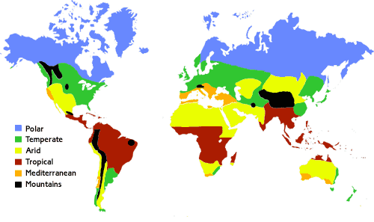
- Make your own weather station to record the weather at home.
- Keep a weather journal, recording what the weather is like each day.
- Create a poem inspired by weather or a storm
- Research a famous storm and create an information poster.
- Create a tornado in a bottle
- Compare our climate to the climate of a country of your choice.
Each area of the world has its own climate. You can see on this map the different climate types.

What is the climate type in the UK?

