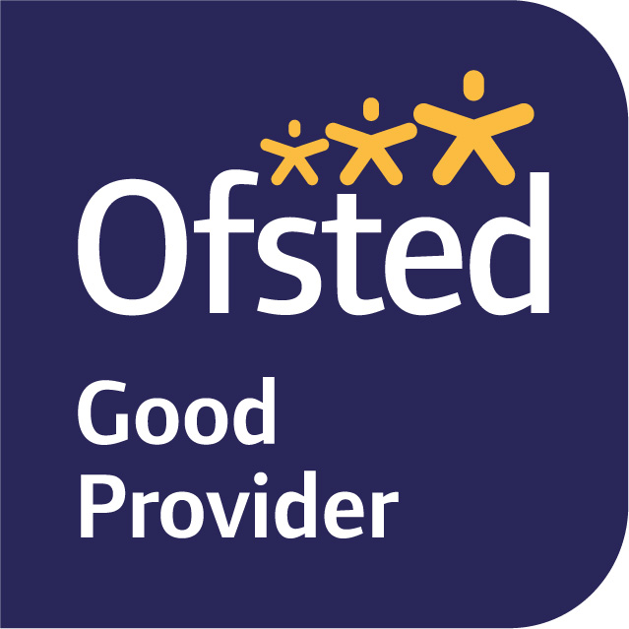

10th September 2021
Dear Parents/Carers,
Welcome to Elm Class! The children are making a fantastic start to the year, exploring their new classroom and outside area.
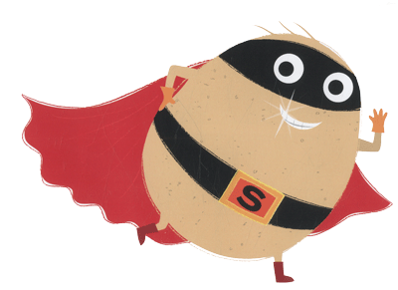
Our learning journey this term is SUPERHEROES! We will be exploring this topic with some exciting writing. We will be using the books, ‘Supertato’, ‘Traction Man’, ‘Awesome Dawson’, ‘Superhero Mum’, Newspaper Boy and Origami Girl’ to inspire us and aid our imaginations in our writing.
We will be learning about the properties and functionality of various materials. With our new knowledge we are going to create and design a cape for our very own Supertato. We will also be learning about Junk Art and looking at various artists and learning how we can recycle junk to create various art forms.
Phonics will be taught daily as a whole-class. We have been recapping phase 3 and are and will continue to teach phase 4 as the term progresses. Phonics is a fundamental part of the children’s learning in Year 1, so we would strongly encourage you to work on this with your children at home where possible. Each child will be provided with their own reading wallet with their yellow reading record book and book banded books to read at home. The reading wallet will also contain your own child’s phonic sounds and key words they need to practise reading. We would encourage your child to read daily. This could be reading their key words or one page of their book, please record what you have done with your child in their reading record. More details about this will be in the whole school reading letter.
We will be continuing to use Power Maths which is a UK curriculum mastery programme designed to spark curiosity and excitement and nurture confidence in maths. Our first unit focuses on the children’s ability to recognise, represent and manipulate numbers to 10. Children will use concrete and pictorial representations to support their understanding and reasoning of numbers to 10.
PE will be on a Wednesday morning. Children will need to come to school in their PE kits. If your child has pierced ears, please make sure that they can either take them out themselves or that they do not wear them on these days as we are unable to allow the children to wear any form of jewellery for PE.
On arrival children are able to select which lunch they will be having that day. Children choose from a range of hot meals. If you are providing your child with a snack or packed lunch, please remember to ensure there are no nuts or sesame seeds in any food your children are provided with.
The children will have an opportunity to eat their snack at break time. When they arrive in class in the morning they will put their snacks in the snack bowl and water bottles in the water box, please make sure snack pots and water bottles are named. It is important your child brings in a water bottle to school every day. Fruit is provided for the children, or they can bring in fruit or vegetables from home.
If your child is being picked up by someone that does not usually pick them up, please let one of us or a member of SLT know who will be on the white gate in the morning. We are aware that sometimes circumstances change during the school day therefore please ensure you phone the office so we are aware of any changes and they will pass the message on.
The children will be read with each week and given the opportunity to change their books by themselves for another book of the same reading band. We will show them how to do this in class and will continue to help them with it until they are confident.
Please make sure all clothing is labelled; the children often find it very difficult to identify their own items if unnamed.
If you have any queries, please do not hesitate to speak to one of us after school.
Kind regards,
Mrs Bishop, Mrs Bedford, Mrs Hamblin

