 | 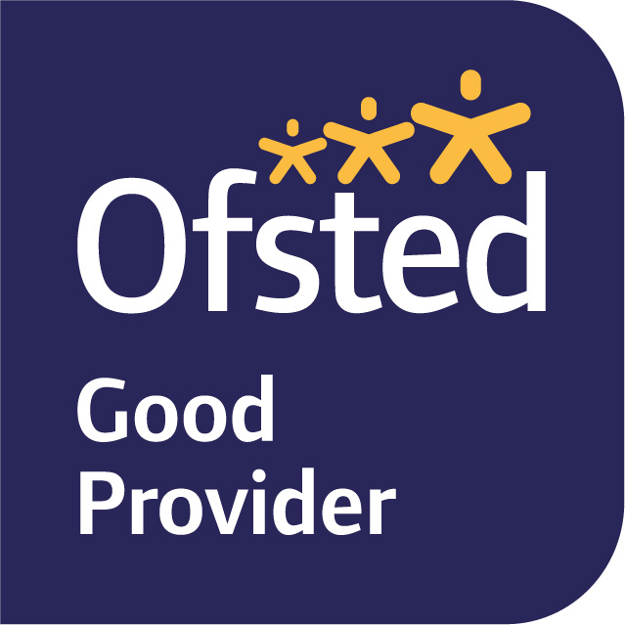

January 2026
Dear Parents/Carers,
Welcome back to Term 3. We had an exciting start to our term, focusing on Healthy Living Week. Our explorations included looking at the importance of washing our hands, the importance of a balanced diet and why we need to get enough sleep. In week 2, we kicked off our learning journey for this term which is ‘India’.
In our English lessons we will be working on a Talk4Writing unit, orally retelling a well-known story then innovating and writing our own version with the help of story maps, changing the characters and ending of the story.
In maths we will be moving further with our learning of addition and subtraction by exploring numbers up to 20. We will be using skills we already have, such as part-whole models and numberlines, to add and subtract different numbers up to 20.
We continue to teach phonics daily. This term we are looking at /er/, /ou/ and /oo/ from the extended code. We will be looking at lots of examples where one sound is spelt in different ways. We will also be continuing with guided reading, where each child will read, as part of a small group, with a class teacher each week. The rest of the class will be focusing on handwriting.
The children continue have the opportunity to visit the library every other Monday to choose a book to take home and enjoy. (This term it will be on 19th, 2nd and 9th.)
In Science this term we will be contrasting and comparing the habitats of deserts, rainforests/jungles with our own local habitat.
In Geography we will be exploring the world around us. We’ll use maps to locate both the UK and India, compare their human and physical features. We will begin to discuss similarities and differences between the two countries. We will also be sharing our own links to other countries, through holidays, family and friends and things that we enjoy. More information to come.
In Art the children will begin to explore printmaking. They will looking at pattern and texture around them and creating their own repeated and rotated prints. We will look to our India topic for inspiration of patterns and colours.
In Music we will be exploring different rhythms through our voices and non-pitched percussion instruments. We will also be singing, keeping the beat and having fun exploring the sounds of different percussion instruments.

In RE our question this term is ‘Who is Jewish and how do they live?’ We will be learning about Jewish worldviews and ways of life. We will learn about texts from the Torah and why they are important to Jewish people today. We will be finding out about the mezuzah and the Shema prayer as well as learning about Shabbat and Chanukah.

PE will be on Wednesday and Thursday. Children will need to come to school in full PE kits on these days. Please ensure that your child has long trousers this term, such as tracksuit bottoms, and a jumper.
We are not setting homework in Year 1 for this term. However, please continue to support your child at home by listening to them read both their decodable book and other books and speaking to them about their learning in school.
Please ensure that your child comes to school each day with a waterproof coat with a hood. This allows us to give the children the maximum amount of time outside each day.
Kind regards,
Mrs Bracher, Mrs Wray, Mrs Hamblin.
Year 1 Team

