“Allow the president to invade a neighbouring nation whenever he deems it necessary to repel an invasion, and you allow him to make war at pleasure” – Abraham Lincoln.
Is it ever right to invade?
Key Vocabulary: the language of a geographer
Compass | An instrument which shows direction using magnetisation.
Eastings | Vertical lines which divide maps from west to east.
Northings | Horizontal lines which divide maps from north to south.
Graticules | Co-ordinates formed on maps using lines of longitude and latitude.
Longitude | Imaginary lines on maps which measure how far east or west a place is.
Latitude | Imaginary lines on maps which measure how far north or south a place is.
States | A nation or territory considered as an organised political community.
Resources | A supply of money, materials, staff, and other assets needed for people and civilisations to survive.
Famine | Extreme lack of food
Key Vocabulary: the language of a historian
Invasion | An unwelcome intrusion into another’s domain.
Occupation | The action, state or period of being taken over by military force.
Territory | An area of land ruled by a person or country/state.
Nazism | The fascist ideology created by Adolf Hitler which persecuted minority groups and especially people of the Jewish faith.
Dictatorship | A government where one person or a small group has absolute power.
Colonisation | The action of settling among and establishing control over the indigenous people of an area.
Indigenous | Existing in a land from the earliest times.
Empire | An extensive group of countries ruled over by a single monarch or government.

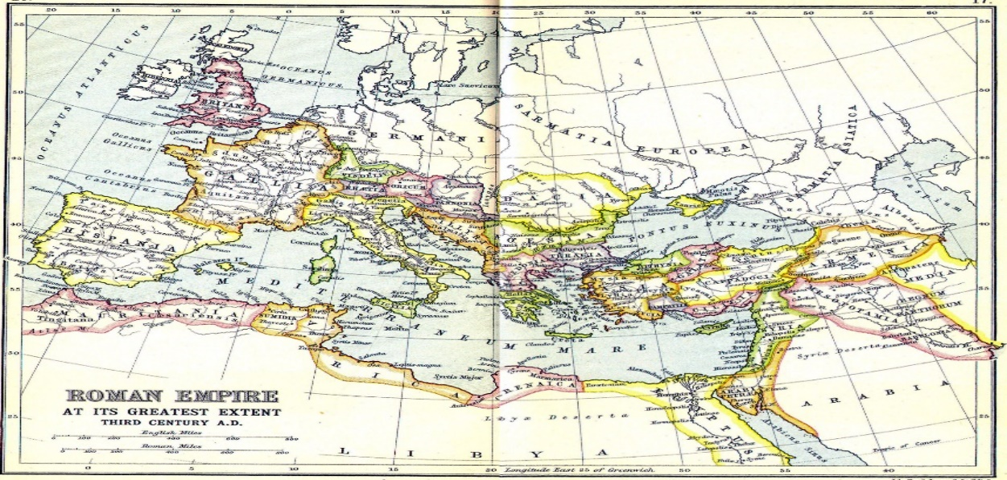
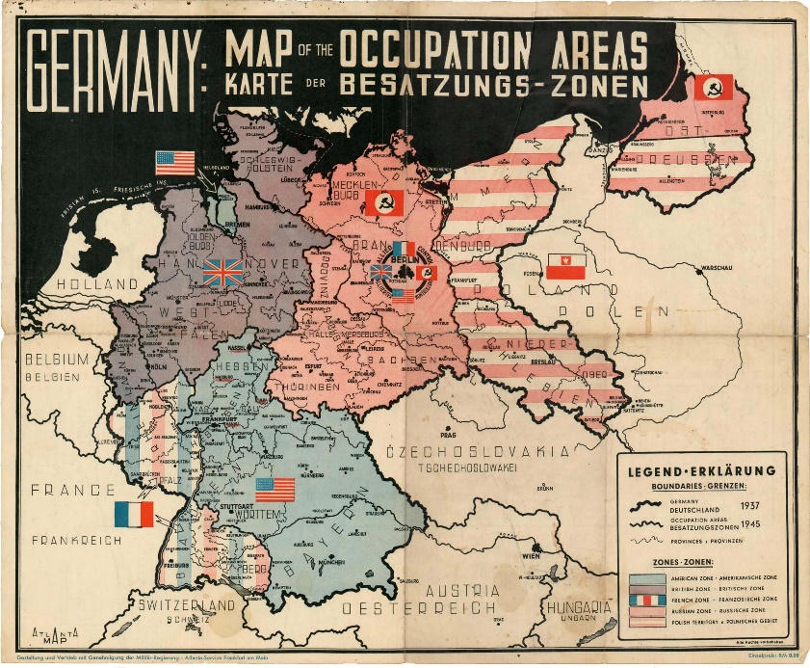
Key Questions
- What is an invasion?
- Why do leaders choose to invade other countries?
- What is the impact of invasion on people who live in occupied countries?
- Is there such thing as a moral invasion?
- Are all invasions malicious?
Overview

This term we are focussing on invasions and the impact they have on the people living in occupied countries. We will be looking at both sides of invasions and the reasons why leaders choose to invade other countries, leading us to our discussion point of whether there can be a valid and moral reason to invade.

