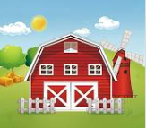
Literacy

Develop good pencil control
Read and write key words
Continue to develop ‘have a go’ writing, sounding out words using our knowledge of letter-sounds
Write super sentences with capital letters, finger spaces and full stops.
Listen to and engage in learning based around the texts ‘What the Ladybird Heard’ and ‘The Gigantic Turnip’.
Explore using a story maps to re-tell a story and change stories
Develop a love for books – we will be taking part in a range of activities linked to World Book Day
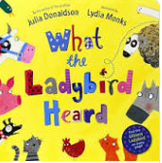
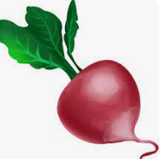
Expressive Arts and Design

Sing a variety of songs exploring vocabulary, pitch, tempo and dynamics and perform in small groups
Explore a range of percussion instruments
Make puppets, masks and props for our own farms/ farm shops (linked to the key texts)
Build farm buildings
Use media and materials in original ways exploring a range of techniques such as texture, form and function
Continue to explore colour mixing primary colours
Talking about how we could improve our work
Invent and adapt stories to make them our own

Physical Development
Practising fine motor skills – cutting, threading, weaving, handwriting patterns, using construction equipment
Using outdoor equipment including the large climbing equipment
Ball skills—throwing, catching and kicking with accuracy
Simple Team Games and partner work including parachute games
Forest school
Mathematics

Subitise (recognise quantities without counting)
Develop our understanding of numbers to 10 – for example, thinking about pairs of numbers that total 5 and then 10. To know subtraction facts to 5.
Compare quantities up to 10 – which is more/less
Begin to explore the concept of subtraction
Recording our work using pictures, numbers and symbols
Explore patterns in numbers

Down on the Farm
Term 4
Understanding of the World

Talk about the role of different people involved in getting food to our plate
Talk about life in the past and how it is different now
Explore story locations and maps
Make our own vegetable soup
Plant our own seeds and observe them grow
Talk about the changing seasons with a focus on Spring
Talk about how Easter is a special time for Christians and how it is celebrated

Communication and Language

Listen attentively to a range of stories thinking about the characters and their actions
Find out about farms and food using a range of non-fiction books making comments about what we have heard
Learn topic related words such as farmer, grow, harvest, produce and transport
Express our thoughts and feelings about the events in books

Personal, Social & Emotional
Development

Show an understanding of their own feelings and those of others feelings and the feelings of others linked to the Zones of Regulation
Work and play cooperatively with others
Talk about Mothers’ Day and who is special in our lives

