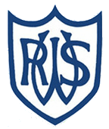 | 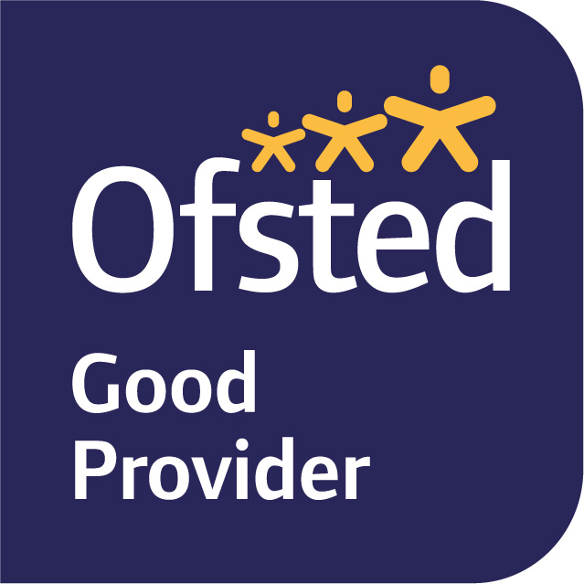

November 2025

Dear Parents and Carers,

Welcome back to Term 2. I hope you all had a restful half term and feel ready for this half term. This term is always a busy one as we look forward to Christmas as well as all the other events such as Bonfire night and Remembrance Day.

Our learning journey for Term 2 is ‘The Ancient Egyptians’ focusing on the question: What do artefacts tell us about ancient Egypt? We will look at how the ancient Egyptians lived and compare that to how we live our lives now. We will learn about the mummification process, the building and purposes of Pyramids, the importance of Egyptian gods in everyday life in ancient Egypt and the significance of discovering Tutankhamun’s tomb. This will link with our work in English.

In English we will be looking at the book ‘Marcy and the Riddle of the Sphinx’ by Joe Todd Stanton, who is a local author from Brighton. We will explore the adventure story and create our own stories in this style. In addition, we will do some non-fiction writing about Tutankhamun and be exposed to various ways to record and present factual information. We will have a weekly spelling focus and use word banks in class to ensure we are spelling words accurately in our written work.

The Year 3 team will continue to read with your children in a variety of ways throughout the week; whole class shared reading, guided reading and 1:1. Please can I encourage home reading everyday to help develop fluency and vocabulary. We will be visiting the library every Wednesday so if your child would like to exchange a book please return them on this day. We have a volunteer coming in twice a week to read with the children so please can they also bring in their sounds write books every day.

In Maths we will start the term by continuing addition and subtraction. We will solidify our knowledge of exchanging and understand the terminology used in word problems to know what operation to use. Closer to Christmas, we will be moving on to look at multiplication and division. This will include multiplying and dividing by 3, 4 and 8. In this unit the children will also have the opportunity to practice these times tables to support their understanding of multiplication and division.

For science this term our topic is light. The children will be encouraged to investigate different light sources and to consider how shadows are formed. We will also be exploring the difference between opaque, transparent and translucent. The children will also create an investigation to find out how reflection works and the relationship between light and reflection.

Our school value this term is resilience. We will link this to our PSHE lessons, considering what this means, and continuing to focus on building positive relationships. This will run alongside our ‘unique week’ explore stereotyping, respecting differences, kindness and communication. We will also continue to remind ourselves and use the Zones of Regulation in exploring our emotions and building toolkits to support them.

Wednesday is still our forest school/PE day so please either come to school in full PE kit or forest school clothing depending on which group you are in each week. We will be starting gymnastics in these lessons.
Our Art this term will have a history focus and link to ancient Egypt. We will use the element of design to create our own Canopic jars using a papier-mâché and layering technique.

In Music, we will explore pitch and tempo using the song, 3 Little Birds. In the unit we will also be responding to musical notation on the glockenspiels.

French will be continued to be taught by Mrs Mannering on Fridays. The children will look at masculine and femine words using une and un, as well as ask and respond to common phrases.

RE will continue to focus on Christianity. We will review our learning from last term about ‘What do Christians learn from the Creation story?’, before starting our enquiry of ‘What is it like for someone to follow God?’

In Computing we will begin learning how to use Scratch and link it to our Egyptian topic. We will also learn how to research effectively on the internet, by searching with key words and learning how to read for information on websites. This unit is embedded with our learning journey on ancient Egypt.

There is a new Term 2 homework grid and termly spellings. Your child will come home with paper copies, but it will also be posted on tapestry.

If you have any queries, please do not hesitate to see us.

Yours sincerely,

Mrs Green

