Who invented that and why? (Transport)

Overview
Language of a Historian
Past | has already happened
Present | is happening now
Timeline | A visual display of a sequence of events in order of when they happened.
Penny farthing | 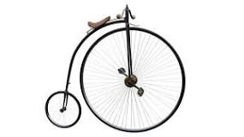  The first bicycle. It has one large wheel.
Transport | carrying people or goods from one destination to another
Travel | moving from one place to another
Vehicle | A thing used for transporting people or goods, such as a car or a lorry.
Technology | Technology is the way we apply scientific knowledge for practical purposes. It includes machines (like computers) but also techniques and processes (like the way we produce computer chips). It might seem like all technology is only electronic, but that's just most modern technology.
Inventor | someone who is the first to think of or make something
Invention | A creation made after studying and experimenting.
Sedan chair | A sedan chair is an enclosed chair for one person carried on two poles by two men, one in front and one behind.
- This term we will be learning about inventions particularly the invention of transport through time.

- We will also have a go at inventing ourselves! In both our DT and our classroom environment we will have opportunities to invent many things.

- This fits nicely with our science topic of materials and their properties which is an important factor to consider when you are inventing something new!

- We will be focussing on how inventors spend a lot of time researching, building and getting things wrong! Emphasising that it is ok to make mistakes and that we can use them to help us learn!

Language of a Scientist
Materials | A physical substance that things are made from.
Flexible | able to bend or be bent easily without breaking
Waterproof | A property of a material which means that it does not let water through and stays dry.
Strong | Difficult to break or destroy
Properties | A characteristic that a material has, e.g strong/ smooth/rough.
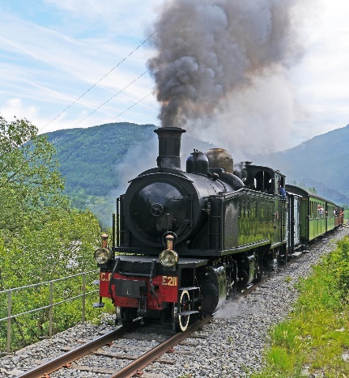

Famous people in transport
George Stephenson | He is most famous for being a civil engineer who invented the first steam locomotive (train).
Karl Benz | He invented the first automobile powered by an internal combustion engine: three wheeled, four cycle, engine and chassis form a single unit.
The Wright Brothers | Inventing, building, and flying the world's first successful motor-operated airplane.
Amelia Earhart | Many early aviation records, including first woman to fly solo across the Atlantic Ocean.
Neil Armstrong | On July 20, 1969, Neil Armstrong made history by becoming the first man to walk on the moon.

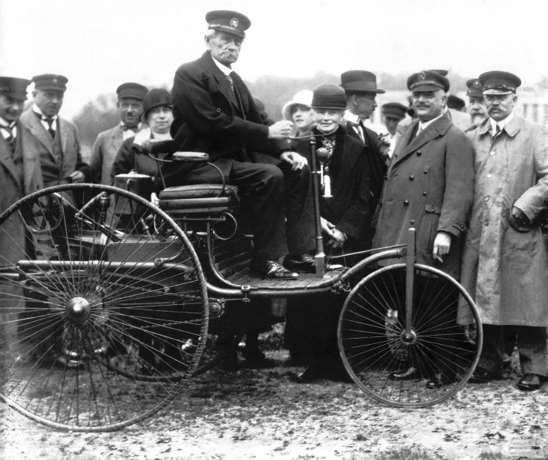
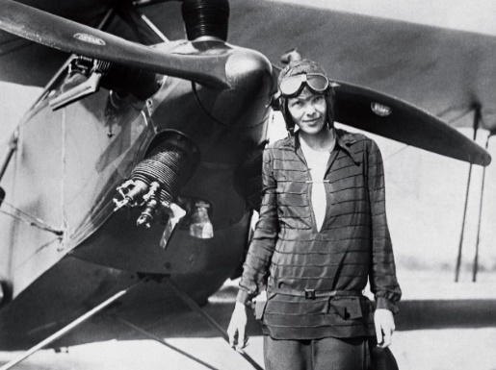
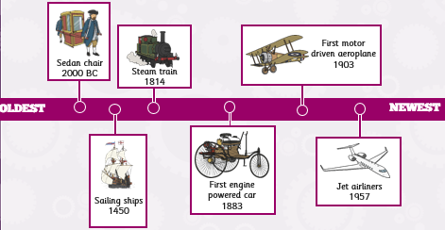
This Photo by Unknown Author is licensed under CC BY-NC-ND

