The Water cycle
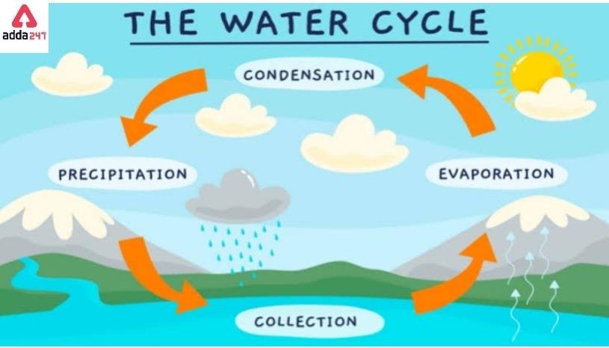
Language of a Scientist
Why is water so important and how does it travel?
What is the weather like in our local area compared to other parts of the world?
Weather, water watchers…

Weather | The day-to-day conditions of the atmosphere. Weather can change quickly. One day it can be dry and the next it may rain.
Climate | Average weather conditions over longer periods and over larger areas. It would take a long time for the typical climate of an area to change.
Temperature | How hot or cold something is, measured in Celsius or Fahrenheit.
Weather Forecast | A prediction of what the weather will be like in the future. This is done by looking at weather patterns.
Meteorologist | A scientists who observes, studies or forecasts the weather
Seasons | The year is divided into four seasons; spring, summer, autumn and winter.
Precipitation | any liquid or frozen water that forms in the atmosphere and falls back to the earth. It comes in many forms, like rain, sleet, and snow.
Evaporation | when a liquid changes into a gas. Liquid water evaporates to become a gas called water vapor.
Condensation | If water vapor cools down enough, it will turn back into a liquid. The exact opposite of evaporation!
Observe | to watch and sometimes also listen to someone or something carefully.
Record | to set something down or preserve it in a way that keeps permanent evidence of it
Rain gauge  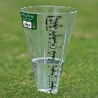 | Instrument used to measure how much rain fall there has been. Usually in ml.
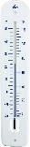  Thermometer | Instrument to measure the temperature.
anemometer 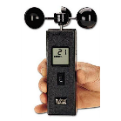 | Instrument to measure wind speed.

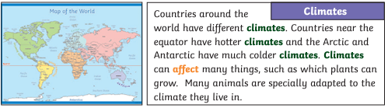

Language of a Geographer
Map | A map is a drawing of all or part of Earth's surface. Its basic purpose is to show where things are. Maps may show visible features, such as rivers and lakes, forests, buildings, and roads.
Compass | A compass is a tool for finding direction.
Key | A map key is a little box of information found at the bottom of a map. It contains an explanation of what the different lines and symbols on the map mean, as well as a scale for you to work out distance
River | A river is the path that water takes as it flows downhill towards the ocean.
Physical features | Human and physical features are things that you can see all around you. Physical features like seas, mountains and rivers are natural. They would be here even if there were no people around. Human features are things like houses, roads and bridges.
Human features
