Year 2 Term 3 Homework Grid
Please consider choosing 2-3 tasks a week to complete.
**Maths and Reading are suggested to be a priority.**
Maths  Target time 15mins | Reading/Writing  Target time 15mins | Topic/Creative  Target time 20mins
**Times table rock stars. We continue to learn our 2’s, 3’s 5’s and 10 times tables. If you need your child’s login please let us know.  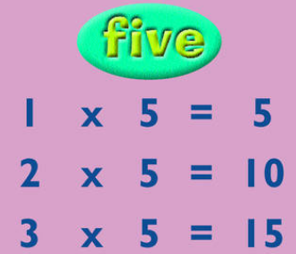 | Let’s use our imagination! Imagine you are writing a letter to a child in India. What would you like to tell them about you? What questions would you like to ask them about their life? You could tell them what your hobbies are, who is in your family, what your favourite food is and what it is like to live in the town of Lewes. | The first week of term we made frozen yogurt bark as part of our healthy living week. Your challenge is to research your own healthy snack and have a go at following instructions to make it! Take pictures and write a review of how it tasted. 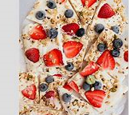
**MYMaths – a series of new tasks are set for the term.  We would recommend you do 1 per week as they align with the teaching in the class e.g. start on 2A, 2B etc. | Practise your spellings. They are:  door past  poor eye  everybody old  would break  great people | Our topic is India this term. Can you do some research on India? Can you find out the answers to the following questions? What continent is India in? What is the population of India? What is India’s official language? What animals might you see in India?  
This term we will be learning about 2D and 3D shapes and identifying their properties. Can you collect objects around your home and identify what shape they are? Can you count how many sides, vertices, edges and faces the objects have. | Write a review of your favourite book.  We know a lot of you are reading books during quiet reading in class and are verbally recommending books to friends to read. We would like you to write a short book review of a book you have read at home or your parents have read to you. The review should tell the possible reader what the story is about but don’t give away any spoilers. You can even give it a rating e.g. 5 stars. if it is a book you loved.
Watch this video clip which talks and shows you how to create a mehndi pattern. Can you create your own pattern to bring into school to show: https://www.youtube.com/watch?v=0sGsN3i00RI 