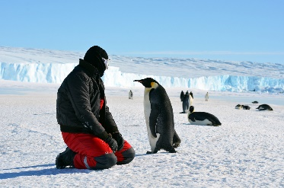
“I believe it is in our nature to explore, to reach out into the unknown. The only true failure would be not to explore at all” – Ernest Shackleton
What do we know about the world and how does it shape the way we live?
ICE

Overview
The polar regions are The Arctic and Antarctica. They are located at the North and South of our Earth.

Life on these regions is much different to life in Lewes! The main differences are temperature and the animals and humans that live there.
Language of a Scientist
Mammal | An animal with fur or hair on its body. They give birth to live animals.  Humans, dogs, elephants and bears are mammals.
Amphibian | An animal that lives on land and in water.  Frogs, toads and newts are amphibians.
Reptile | An animal that has dry scales.  Lizards, crocodiles and turtles are reptiles.
Carnivore | An animal that eats other animals. They have sharp teeth so that they can eat meat.  Lions, polar bears and sharks are carnivores.
Herbivore | An animal that eats plants.  Rabbits, elephants and giraffes are herbivores.
Omnivore | An animal that eats other animals and plants.  Foxes, turtles and bears are omnivores.

Language of a Geographer
United Kingdom | The United Kingdom is a country of western Europe. It is made up of four parts: England, Scotland, Wales, and Northern Ireland
Equator | an imaginary line around the Earth that goes exactly midway between the North Pole and the South Pole and divides it into two equal halves, the Northern Hemisphere and the Southern Hemisphere.
Thermometer | A thermometer is an instrument for measuring or showing temperature (how hot or cold something is). One type of thermometer is a narrow, concealed glass tube containing mercury or alcohol which extends along the tube as it expands.
Iceberg | An iceberg is a large piece of ice floating in the sea. They are generally found in cold water near the North or South Pole
North pole | The North Pole is the point that is farthest north on the planet Earth.
South Pole | The South Pole is the point that is farthest south on the planet Earth.
