 | 

June 2026

Dear Parents and Carers,

Welcome back to Term 6!

English and maths
In Literacy, we are focussing on the story ‘The Lighthouse Keeper’s Lunch’. We will be carrying out some drama activities and writing our own versions. We will also be writing weather reports which we will perform in front of the rest of the class.

This term in maths, we will be looking at problem solving using all of the skills we have learnt this year such as addition, subtraction, multiplication and division. We will also be focusing on time, the children will be taught to tell the time to the nearest 5 minutes, including quarter to and quarter past.
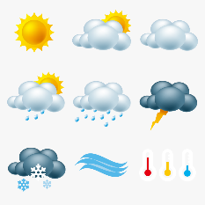

Foundation subjects
This term we are looking at weather. We are going to be conducting many fieldwork investigations and are focussing on data collection e.g how much rainfall there is or the how the temperature differs over time. We will also be learning about the water cycle. We will be using maps to locate the River Ouse to help us understand the water cycle and how water travels. We will be going to the Science Observatory in Herstmonceux to take part in a workshop about weather. We will also explore all the hands on exhibits which will consolidate a lot of our science learning this year.
In Art we will be looking at the types of cloud and making an identifying sheet as well as creating some stormy pictures. In music we will interpret different pictures of weather and compose our own pieces of music to complement each one.

We will still be attending forest school again this term, with the final session for group 2 w/c 8.7.2026, if you are able to volunteer to help please let Katie know. The children who are not attending forest school will be taking part in PE that day so need to attend school in their PE clothes.

I am looking forward to a fun, sunny term!

Kind regards,
Mrs Bishop, Mrs Bedford, Ms Hart.

