 | 

Dear Parents and Carers,
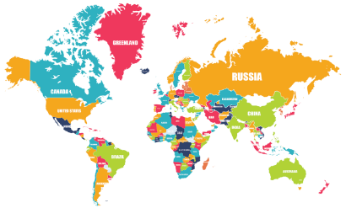
In Cherry Class, we’ve had an exciting start to the term, focusing on healthy living during Healthy Living Week. Our explorations included a hands-on look at germs and the importance of washing our hands. We've also discussed the importance of a balanced diet and maintaining a healthy mind. Next week, we’ll be kicking off our topic with an exciting 'flight' to India!
Throughout this term, we’ll be embracing the role of geographers as we explore the world around us. We’ll use maps to locate both the UK and India, and compare their human and physical features. This will help the children understand the differences and similarities between the two countries. In Science, we are diving into the world of animals, including humans. We’ll learn about their basic needs for survival, life cycles, and food chains.
Creativity is also at the heart of our learning this term. In Art, we’ll be creating bright, patterned artwork, beginning with mehndi designs, followed by rangoli patterns and shadow puppets. In Music, we will explore diverse musical traditions from around the world and learn about the various instruments used in different cultures.
In Maths, we’ve begun exploring the properties of 2D and 3D shapes, learning how to identify and describe them. If you'd like to learn more about how we teach this in class, please feel free to check out the videos on this link. You don’t need to work through these with your child, but they can offer useful insights into the vocabulary and teaching strategies we use in our lessons.
In English, we’re focusing on the story ‘Chapatti Moon’, which follows a similar pattern to ‘The Gingerbread Man’. The children will eventually create their own original stories inspired by this structure. We’ll also be reading two traditional Indian folk tales: ‘The Tiger Child’ and the story of ‘Rama and Sita’.
For PE, lessons will take place on Wednesdays and Fridays. Wednesdays will be ball skills and Friday’s we will focus on developing the children’s sending and receiving skills. Some of these lessons will take place outside, so please ensure your child wears a suitable jumper on these days to stay comfortable.
In Music our topic is ‘Music around the World’ we will be listening to music from around the world, exploring tempo understanding that music can be at different speeds. We will learn that music diversity in each country is vast and not all music from a single region will sound the same. We have an Indian Dance workshop to support our understanding of both music and dance in India.
Thank you for your continued support, and I look forward to an exciting term ahead with your child!
Kind regards,
Mrs Bishop, Mrs Bedford and Ms Hart

