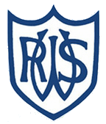 | 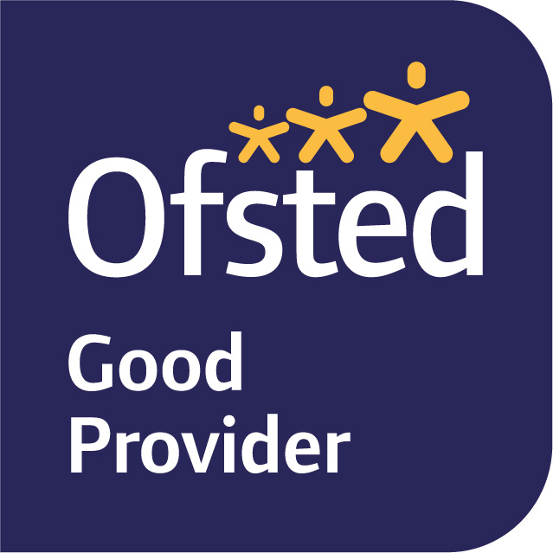

November 2025
Dear Parents and Carers,
We hope everyone has had a lovely half term;
Our enquiry question this term is ‘How did children face adversity in the Victorian Times?’, which we will be exploring through our History, DT, Guided Reading, and English lessons this term. We will be developing our historical skills through using sources to discover how children lived during the Victorian Times and how it differs from today. We will also expand our knowledge of Victorian life through our exploration of the texts ‘Another Twist in the Tale’ and ‘A Christmas Carol’ in Guided Reading. During these sessions, children will also develop their retrieval and inference skills.
In English, we will first be focussing on constructing balanced arguments, and considering whether or not fireworks should be banned due to their impact on the environment. As we progress through the term and learn more about the lives of Victorian children, we will then begin to work on creating newspaper articles detailing the various incidents which could happen to children working in the Victorian Times. To complement our enquiry question, we will begin by looking at real newspaper clippings which discussed children being in accidents whilst working to help support their families. We will then deconstruct the different features which make up a newspaper article, before bringing our work together in our final piece.
In Maths, we will be focusing mainly on fractions: multiplying, adding, subtracting and dividing them, as well as consolidating our knowledge of how to simplify and convert them. We will continue to use the Power Maths scheme, as it takes a mastery approach and allows for whole-class discussions about different aspects of number. Further practice will also be facilitated through twice-weekly Early Morning Maths sessions. Please continue to encourage your child to continue to practise their times tables outside of school, as they are the foundation for so many of the topics covered this year.
In Science, we will be learning about Electricity, with a particular focus on circuitry. We will consolidate our knowledge of different circuit symbols, as well as explore the reasons why circuits may not work as intended. We will also be learning about current and voltage and conducting an experiment to see how increasing the voltage affects the other components in the circuits
In DT this term, we will be researching, designing, constructing and evaluating circuit-powered vehicles. This will link to both our work with circuitry in Science and our knowledge of Victorian life developed in our History lessons.
PE is on a Monday and Thursday this term. For both PE sessions, please make sure your child is wearing a full named PE kit to school (including trainers or plimsolls). We are unable to allow the children to wear any jewellery during PE, so if your child has pierced ears, please can they either not wear their earrings to school, or be able to take them out. It would be useful if they could have a small pot or bag to keep these in to ensure they do not get lost. Newly pierced ears can be taped at home on these days. If your child is unable to do PE for any reason, please inform us in writing or tell us on the gate.
In Music we will be studying the samba music and traditions of Brazil. We will be thinking about pulse and rhythm, and using un-tuned percussion to play different rhythms, working co-operatively as a group.
PSHE this term focuses on building up resilience and staying true to who we are. In French, we will be learning and consolidating vocabulary about animals. In RE, we will be exploring the reasons why only some people believe in God, and why others may not. In Computing, the children will be coding chase games using Scratch.
MyMaths homework will be set on Fridays to be completed by the following Wednesday. Spelling, Topic or English homework will be uploaded onto Seesaw on Thursdays.
If you have any queries, please do not hesitate to see one of us.
Best wishes,
Miss Wilkes, Mrs Hamilton, and Mrs Allcorn
– The Year 6 Team

