Language of a historian
Adversity | A difficult or unpleasant situation.
Primary source | Raw materials of history – original documents and objects that were created at the time of the period. These include statues, letters, diaries, coins, and clothes.
Secondary source | A document or recording that discusses a primary source. These include textbooks, dictionaries, essays, and journal articles.
Copperplate handwriting | A cursive handwriting style Victorian children were taught in school.
Cane | A thin wooden rod used to beat children with as a punishment in Victorian schools.
Shilling | A type of coin used in the Victorian era, equivalent to about 5p today.
British Empire | A collection of countries and states which Britain invaded and colonised.
Poverty | Not having enough resources to meet your needs; being extremely poor.
Workhouse | Large buildings which housed homeless and impoverished people in exchange for work.
Era | A long and important period of history.
Mill | A building which houses machinery to produce cotton, flour, etc.
Language of a geographer
Rural | Areas in the countryside, areas not in towns or cities.
Urban | Areas within towns or cities.
Thames | The name of the river which flows through London.
Community | A group of people living in the same place or having a particular characteristic in common.
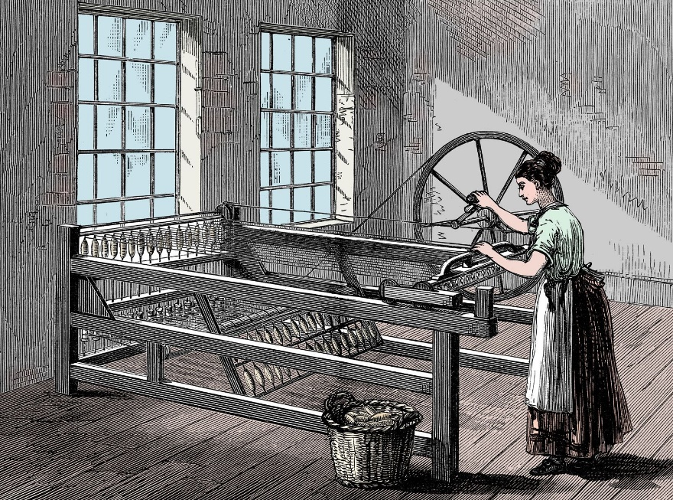
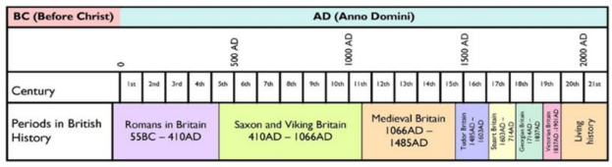
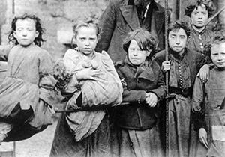
1901
Queen Victoria dies. The Victorian era ends
1891
Education is made free for children 5-13
1880
Education Act requires all children to attend school
1870
Dr Barnado opens his first home for boys
1844
Factory Act lets children work from age 8
1840
First ‘ragged schools’ set up
1837
Queen Victoria is crowned
How did children experience adversity in the Victorian Times?
- How did children face adversity at school?
- What types of jobs did children have in the Victorian Times?
- What injuries did children sustain whilst at work?
- What was life like in the Workhouses?

Key Questions to ask yourself:
The Victorian era saw the United Kingdom become the first global industrial power, producing much of the world’s coal, iron, steel and textiles. Unfortunately, this was achieved by using children as cheap labour. Victorian children worked in mines, in cotton mills, as chimney sweeps, in factories and as domestic servants.

Only some children were lucky enough to go to school – most families couldn’t afford this luxury.

Overview
“Education never ends, Watson. Life is a series of lessons, with the greatest for the last” – Arthur Conan Doyle

