 | 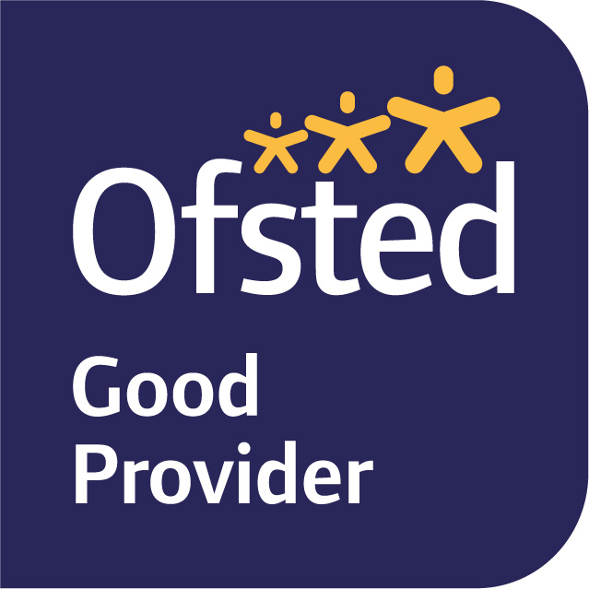

January 2025
Dear Parents and Carers,

Welcome back and Happy New Year!

Our enquiry question this term is ‘Is it ever right to invade?’, which we will be exploring primarily through our Geography, Art, Guided Reading, and English lessons this term. We will be developing our geographical skills by interpreting maps; analysing the topography of countries using atlases and computer mapping; and using graphs to collect and present information. Through this, we will be able to better develop our understanding of why certain invasions occurred and their impact on the affected countries. We will also expand our understanding of the impact of invasion through our exploration of the text ‘Resist’ in Guided Reading, which chronicles the life of a young Audrey Hepburn in the Nazi-occupied Netherlands. During these sessions, the children will also develop their retrieval and inference skills.

In English, we will first be focussing on creating written advertisements; using our knowledge of different persuasive writing techniques to make it as effective as possible. As we progress through the term and have a greater understanding of the impact of invasion, we will then begin to work on creating diary entries from the point of view of someone who is experiencing an occupation of their country, like Audrey experiences in Resist. Grammar will be taught discretely twice a week in Early Morning Work sessions, and in English lessons to support our writing. As per the children’s request, we also have a Grammar booster session each week to support with SATs.

In Maths, we will be learning about ratio and algebra, and developing our ability to identify questions which require these skills. We will continue to use the Power Maths scheme, as it takes a mastery approach and allows for whole class discussions about different aspects of number. Further practice will also be facilitated through twice-weekly Early Morning Maths sessions. Please continue to encourage your child to continue to practise their times tables outside of school, as they are the foundation for so many of the topics covered this year.

In Science, we will be learning about Light. Throughout the term, we will be learning about the way light travels, especially through the eye, and different types of light sources, and the relationship between light and shadows.

In RE, we are learning about Hinduism and focusing on the question "Why do Hindus want to be good?", including exploring the key concepts of Karma, Dharma and samsara and how this might affect how a Hindu chooses to live their life.

In Music, we will develop our understanding of music that was played and listened to during World War and the importance of music, dancing, broadcasting, and the wireless during the Second World War. We will explore the swing/big band era and the instruments that were used, we will learn to sing a song (Hey Mr Miller) in the style of Glenn Miller/Big Band. We will learn to play some jazz/swing on tuned percussion and improvise in a jazz/swing style.

PE is on a Tuesday this term, and we are swimming. Please ensure that your child has suitable swimwear for each session. We are unable to allow the children to wear any jewellery during PE, so if your child has pierced ears, please can they either not wear their earrings to school, or be able to take them out. Newly pierced ears can be taped at home on these days. If your child is unable to do PE for any reason, please inform us in writing or tell us on the gate.

MyMaths homework will be set on Fridays to be completed by the following Wednesday. Spelling, Topic or English homework will be uploaded onto Tapestry on Thursdays.

If you have any queries, please do not hesitate to see one of us.

Best wishes,

Miss Wilkes, Mrs Hamilton and Mrs Allcorn
- The Year 6 Team

