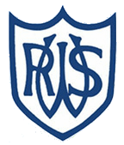 | 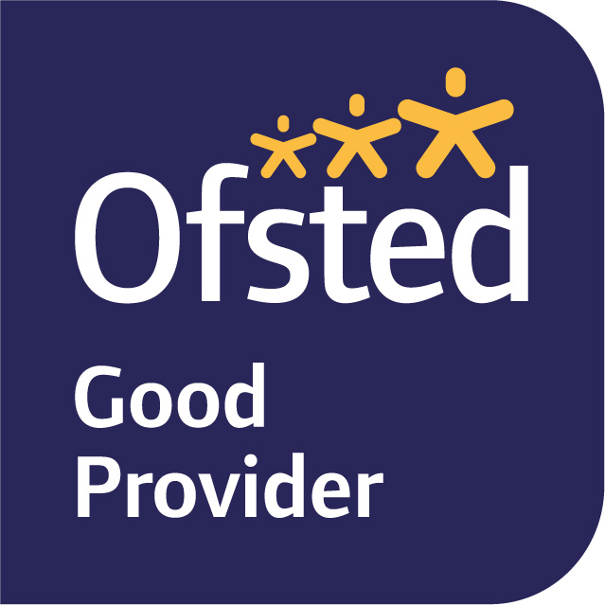

January 2026

Dear Parents and Carers,

Welcome back to term 3. I hope you all had a fun and restful Christmas and New Year. We have a fun term ahead of us with lots of interesting topics to explore together. Our school trip to the Brighton Museum on 28th January. An MS Form will be going out with more information.

Our topic for term 3 is The Stone age to The Iron age. This is a topic which covers millions of years of history. Throughout the topic we will be considering how life has changed since the Stone Age. We will be exploring Skara Brae, considering the diet of a Stone Age person, investigating Iron Age Hillforts and identifying the differences between the three different periods, Stone Age, Bronze Age and Iron Age.

In English, we are starting the term looking at the book ‘How to Wash a Wolly Mammoth’ by Michelle Roberston. We will use imperative verbs to create our step by step instructions of washing this prehistoric animal as well as using engaging and creative language. We will then be using our knowledge of Stone Age, Bronze Age and Iron Age to create Kennings poetry. Our library day is on Wednesdays this term.

In maths we are going to look at multiplication and division. We will continue to embed the times table facts of the 3, 4 and 8’s by practicing our fluency daily. We will be looking at using formal methods such as the column method to work out calculations involving 1 and 2 digit numbers.

For science this term we are looking at animals, including humans. We will be exploring skeletons and muscles and comparing these between different animals. We will also be thinking about a balanced diet and how this may be different for different people and animals.

We have dance with Zara on Mondays this term and then we will be looking at ball games such as netball in our sessions on Wednesdays. Please ensure your child comes to school in PE kit on these days. Some of our lessons may take part outside so please also ensure your child is dressed appropriately for this.

In PSHE, we will be revisiting some learning about families and friendships. This will include breaking problems down into small, achievable resolutions and goals. We will also be linking our learning to Healthy Living Week and Science, understanding how a healthy lifestyle includes physical activity rest and diet.

We continue to teach our foundation lessons over the term. In Music we will continue to expose children to different types of music, use specific vocabulary to respond to music and explore rhythm and beat on tuned and untuned instruments. In French we learn greetings and commands, as well as increase our vocabulary of animals, colours and numbers. In Computing we will use iPads to continue our learning of coding using Sparks Academy. In RE will learn about Islam by considering the question, ‘How do festivals and worship show what matters to a Muslim?’. Our Art will be taught by Mrs Mannering. We will be examining ancient cave paintings to learn about the significance of the images before creating our own rock / cave paintings.

If you have any queries, please do not hesitate to speak with us at the gate or through emailing the office.
Mrs Green

