Language of a historian
Anderson shelter | A small shelter made from corrugated steel to protect people from air raids.
Allied Powers | The countries who fought the Axis Powers (Britain, France, Soviet Union, USA)
Axis Powers | The countries who fought against the Allied Powers: Germany, Italy and Japan.
Blackout | The turning off of all lights at night to reduce the risk of bombing.
Blitz | The prolonged period of German air raids on Britain.
Fascism | A political system where a dictator
Führer | German word meaning ‘leader’. Hitler gave himself this title in 1934.
Holocaust | The mass murder of 6 million Jewish people by the Nazis.
Luftwaffe | The German air force during WWII.
Nazi | Short for National Socialist Party, name given to supporters of Hitler.
Propaganda | Information used to promote a political cause or point of view.
Rationing | Controlling the supply of necessities to avoid or reduce shortages
Main participating countries
Allied Powers |  | Axis Powers
Country | Flag | Country | Flag
France |  | Germany | 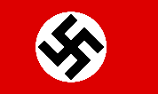
UK | 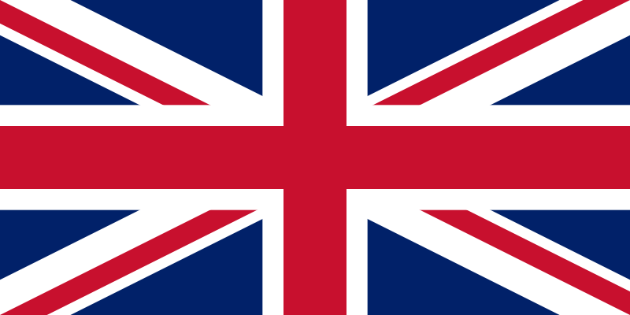 | Italy | 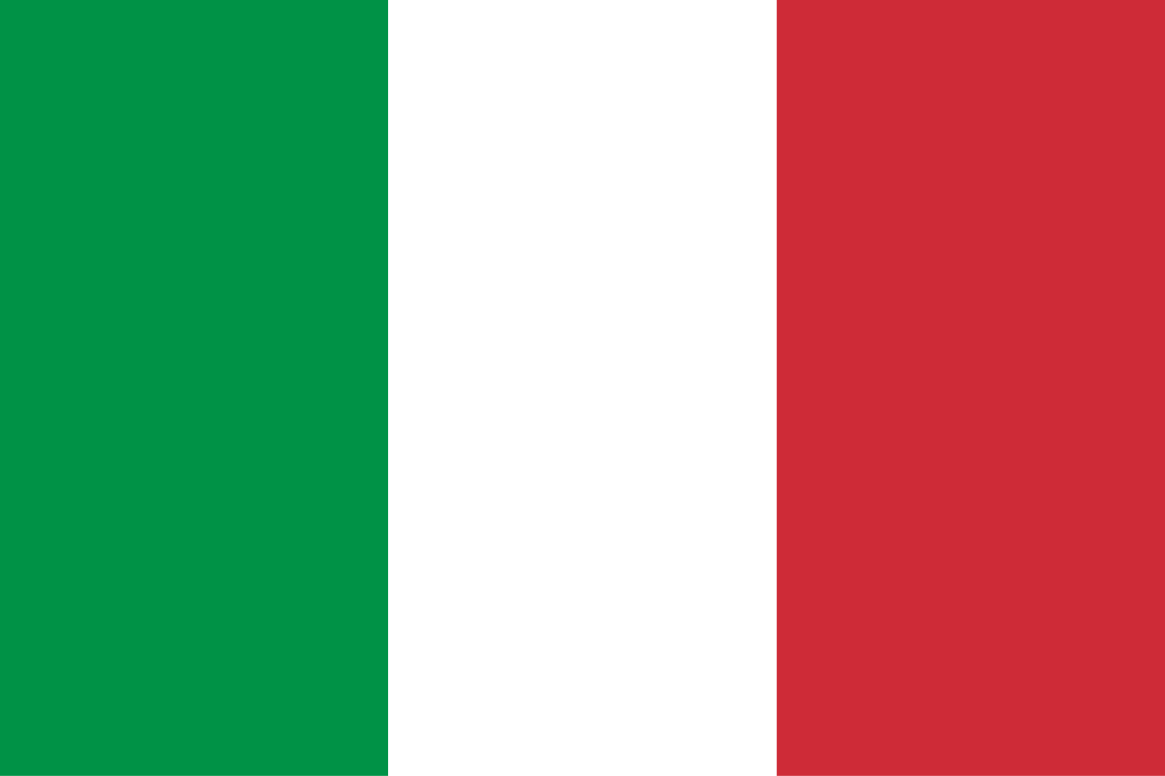
Soviet Union | 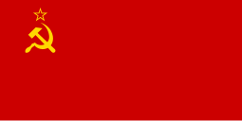 | Japan | 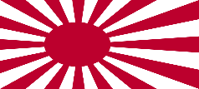
USA | 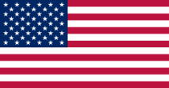
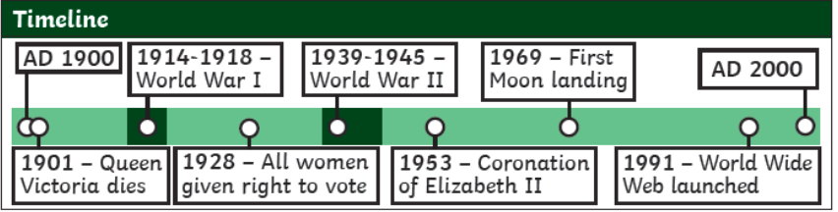
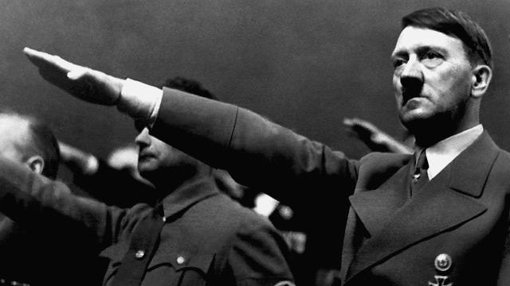
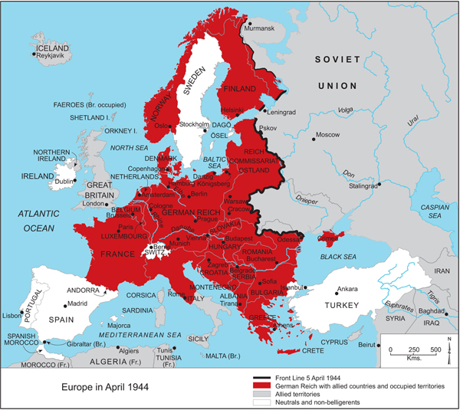
1945
Japan surrenders – WWII is over
1945
US drops atomic bombs on Japan
1945
Germany surrenders
1944
D-Day: the Allies invade Germany
1941
Japan attacks Pearl Harbour – US joins the Allies
1941
Axis powers attack the Soviet Union
1941
The Battle of Britain
1939
Germany invades Poland – WWII begins
1940
Germany takes over most of Western Europe
‘The truth is incontrovertible. Malice may attack it, ignorance may deride it, but in the end, there it is.’ – Winston Churchill
Key questions to ask yourself:
- What were the causes of WWII?
- Who was on each side?
- What was rationing like for civilians?
- What was life like for evacuees in the countryside?
What was life like in Britain during World War 2?
Overview:
The Second World War (1939-1945) was a global conflict between two main factions: the Allies and the Axis powers. Nearly all of the world’s countries participated and it was the most destructive global conflict in history.

