Year 2 Term 6 Homework Grid
Please consider choosing 2-3 tasks a week to complete.
**Maths and Reading are suggested to be a priority.**
Maths  Target time 15mins | Reading/Writing  Target time 15mins | Topic/Creative  Target time 20mins
**Times table rock stars. We have been learning our 2’s, 3’s 5’s and 10 times tables. Logins were sent home on the last day of term.  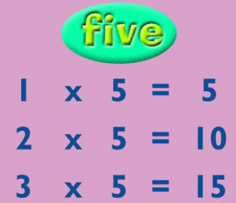 | In our guided reading this term we will be reading The BFG.  Are there any other Roald Dahl books you have read or reading at home? Write a review of the book for your peers to read. Will your book get 5 stars?  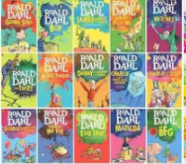 | In Geography we are going to be learning why rivers are important.  We will be identifying key features of rivers. We will be looking at both the physical and human features around rivers.  Can you go on a walk alongside a river? Can you identify human and physical features.  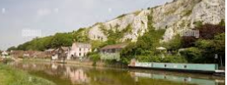
**MYMaths – a series of new tasks are set for the term.  We would recommend you do 1 per week as they align with the teaching in the class e.g. start on 2A, 2B etc. | We will continue to upload the weekly spellings on tapestry.  | Science  In Science this term we are going to become weather watchers.  Can you keep a record of the weather each day this term? We will also be learning about the water cycle. Can you create your own image of the water cycle.  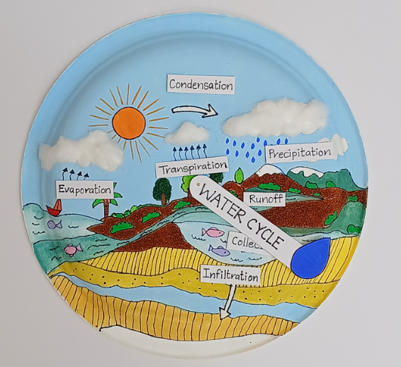
The children are doing really well with their joined up writing. Below is a link to support them as they pratice at home. https://www.teachhandwriting.co.uk/continuous-cursive-beginners-choice-4.html Please select continuous cursive.

