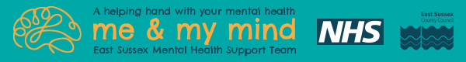

Introducing Lily Stevanovic - Parent /carer Practitioner from Me & My Mind
Lily from ‘Me and My Mind’ team (part of East Sussex Mental Health Support Teams), would like to set up free sessions for parents/carers to support their child’s mental health and emotional wellbeing.
Lily offers workshops, themed coffee mornings, 1:1 drop-in sessions, online and recorded webinars and at times short courses on specific subjects. Firstly, she would like to know what would be most valuable for you and your child right now.
Workshops/coffee mornings could include things such as, “Taming the Worries”, “Tricky Mornings”, “Thriving Through Change” or getting advice and support on Children’s Wellbeing – workshop that covers 5 ways to wellbeing, sleep, food, digital media and much more. In Secondary schools, she also supports parents/carers around exam stress with the Stress Less – Exam Workshop.
Please click: https://forms.office.com/e/QYXhLwZ2NG or scan QR code below to complete 1-minute survey to find out what is on offer and to express your current support needs. You will find the same QR code on many school platforms. For further information or to find out more speak to the school office.


