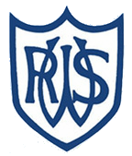 | 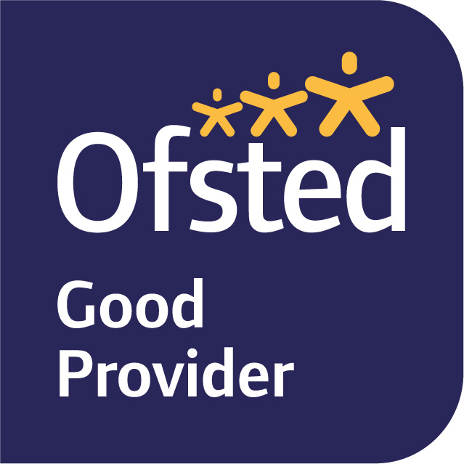

September 2025
Dear Parents and Carers,

Welcome to Year 6! It has been wonderful to see the children settle in so well and get stuck into this term’s learning.

Our first enquiry question in this year is ‘How did the Ancient Greeks change the world?’, which we will be
Exploring through our History, DT, Guided Reading, and English lessons this term. We will be developing our historical skills through evaluating the extent to which the legacy of different aspects of Ancient Greece is still present today. We will also expand our knowledge of Ancient Greek terminology through our exploration of the text ‘Percy Jackson and the Lightning Thief’ in Guided Reading. During these sessions, children will also develop their retrieval and inference skills.

In English, we have started this term focusing on the picture book ‘Varmints by Helen Ward. The book tells the story of a rabbit-like creature living in a world suddenly changed due to industrialisation and human intervention. This text is part of a whole-school focus based on the theme of environmentalism, and the children will use this to support them in identifying the impact humans have on our world and what we can do to minimise this impact. In addition to ‘Varmints, we will be using the text ‘The Orchard Book of Greek Myths’ by Geraldine McCaughrean to support us in writing our own suspense-filled myths. This text is a compilation of some of the most prolific Greek myths, from ‘Pandora’s Box’ to ‘Jason and the Golden Fleece’, written to be more accessible to children. Using a Talk for Writing approach, the children will first identify key features by exploring a range of different myths, before using them in their own writing. Grammar and punctuation will be taught both in Early Morning Grammar sessions twice-weekly in the morning, and within English lessons to support pupils with their writing. In Year 6, spelling is taught discretely each day. Please support your child with their spelling by encouraging them to use and practice the words which will be uploaded onto Tapestry weekly.

In Maths, we will be focusing on Number: revising and consolidating our knowledge of place value and the four operations (addition, subtraction, multiplication and division). We will continue to use the Power Maths scheme, as it takes a mastery approach and allows for whole-class discussions about different aspects of number. Further practice will also be facilitated through twice-weekly Early Morning Maths sessions. Please encourage your child to continue to practise their times tables outside of school, as they are the foundation for so many of the topics covered this year.

In Science, we will be learning about the different parts of The Circulatory System and linking its discovery with the legacy of Ancient Greek medicine. We will also be exploring the importance of a healthy diet and exercise as well as the impact drugs have on our bodies. In Art this term, we will be researching about, designing, creating and evaluating Ancient Greek vases from clay.

PE is on a Tuesday and Thursday this term. For both PE sessions, please make sure your child is wearing a full named PE kit to school (including trainers or plimsolls). We are unable to allow the children to wear any jewellery during PE, so if your child has pierced ears, please can they either not wear their earrings to school, or be able to take them out. It would be useful if they could have a small pot or bag to keep these in to ensure they do not get lost. Newly pierced ears can be taped at home on these days. If your child is unable to do PE for any reason, please inform us in writing or tell us on the gate.

In Music we will be learning about different time signatures and the duration of different notes, and how these are shown in musical notation. We will be using tuned and un-tuned percussion instruments to play notes of different duration, by reading the music and playing by ear. We will be listening to a range of music from different genres, and finding out about the music of Ancient Greece!

PSHE this term focuses on respect and challenging stereotypes, as well as reinforcing the Zones of Regulation code. In our language sessions, we are going to delve into the world of Classical languages by learning some Ancient Greek. In RE, we will be exploring the story of Genesis, the conflicts between the Creation Story and cosmology, and how the two can coexist. In Computing, the children will learn all about Steganography (the art of hiding messages in plain sight) and how it has developed since its invention during Ancient Greek times.

MyMaths homework will be set on Fridays to be completed by the following Wednesday. Spelling homework will be uploaded onto Tapestry on Wednesdays and will consist of our focus spellings for the week.

If you have any queries, please do not hesitate to see one of us.

Yours sincerely,

Miss Wilkes (Monday afternoon-Friday afternoon) and Mrs Hamilton (Monday morning)
– The Year 6 Team

